VIGO COUNTY
HEALTH DEPARTMENT
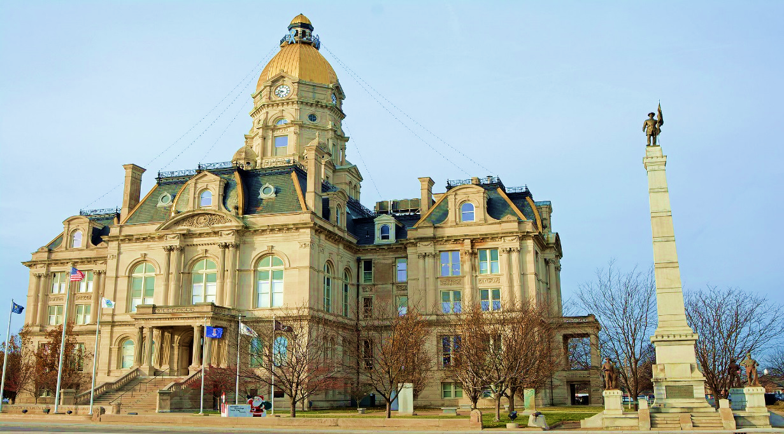
2018
ANNUAL REPORT

The Vigo County Health Department serves to promote, protect and provide for the well-being of the citizens in Vigo County

BOARD OF HEALTH

For almost 50 years, the Vigo County Health Department has provided the citizens of Vigo County with the very best public health services possible. Today, those services have expanded into areas our predecessors never imagined, challenging us to keep pace with the demands of an ever changing environment and population. The Vigo County Health Department has continued in the successful tradition established under the leadership of its Board of Health. Members of the Board of Health have roots in medicine, law, business, industry, labor and social services. Maintaining communication between the governing body and staff members has been instrumental in relating regulation and procedures that best serve the community. The Vigo County Board of Health is appointed by elected officials in order to represent the needs of the community. The Vigo County Board of County Commissioners appoint all seven members of the board, no more than three from the same political party.
2018 BOARD OF HEALTH

Jared Farnsworth, Chair
Jeff Depasse, Vice-Chair
David Runyan
Brian Garcia
James Turner, D.O.
Custodio Lim, M.D.
Sarah Ciolli, R.N.

PUBLIC HEALTH IN VIGO COUNTY
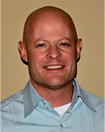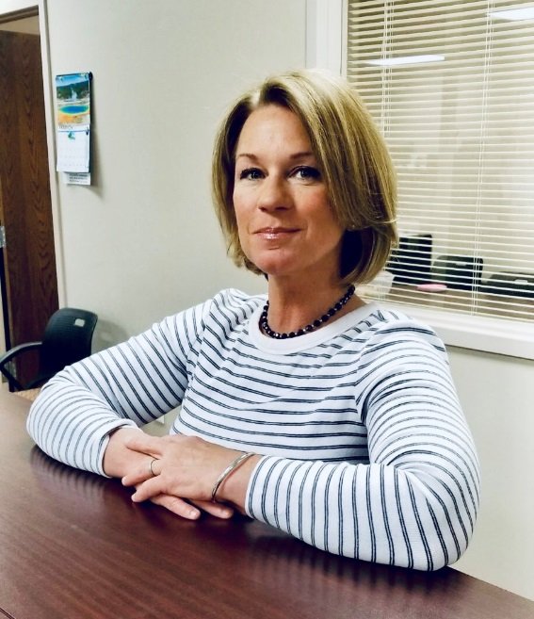
Dr. Darren Brucken Joni Wise
Health Officer Administrator

Vision: Healthy People in Healthy Communities
Mission: Promote physical & mental health, prevent disease, injury and disability
Public Health Goals
- Prevents epidemics and the spread of disease
- Protects against environmental hazards
- Prevents injuries
- Responds to disasters and assists communities in recovery
- Assures the quality and accessibility of health services

Essential Public Health Services
- Monitor health status to identify community health problems
- Diagnose and investigate health problems and health hazards in the community
- Inform, educate and empower people about health issues
- Mobilize community partnerships to identify and solve health problems
- Develop policies and plans that support individual and community health efforts
- Enforce laws and regulations that protect health and ensure safety
- Link people to needed personal health services and assure the provision of health care when otherwise unavailable
- Assure a competent public health and personal health care workforce
- Evaluate effectiveness, accessibility and quality of personal and population-based health services
- Research for new insights and innovative solutions to health problems

Programs and services are developed, implemented, evaluated and revised (if needed) to enable carrying out the essential public health services and meet the public health goals.

VIGO COUNTY HEALTH DEPARTMENT

Darren Brucken, M.D., Health Commissioner

Administration
Joni Wise, Administrator
Travella Myers, Deputy Administrator
Rhonda Coombs, Bookkeeper
Beth Morse, Purchasing Clerk

Environmental Health Division
Travella Myers, Supervisor
Theresa Jackson, Food Specialist
Amanda Bales, Food Specialist
Mark McClintock, Wastewater Specialist
Marci Shaw, Lead Specialist
Steve Thompson, Wastewater Specialist

Health Education/Media Coordination
Roni Rozina

Vector Control Division Vital Statistics Division
Mike Grayless, Supervisor Loretta Nicoson, Supervisor
Tony Grayless, Assistant Supervisor Cheryl Clements, Registrar
Warren Sweitzer, Assistant Brandie Draser, Registrar
David Higgins, Assistant Brooke Foltz, Registrar
Logan Edwards, Assistant Jessica Kiger, Registrar
Kim Edwards, Secretary
Chris Schalburg, Seasonal

Nursing Division
Catherine Brown, M.D., Pediatrician
Andrea Craft, RN, Staff Nurse
Twyla Spidel, RN, Staff Nurse
Chelsea Willis, RN, Staff Nurse
Dolly Moss, Secretary
Teresa Bechtel, Immunization Registry Clerk
Rhiannon Moore, Insurance Billing Specialist

FINANCIAL REPORT FOR 2018

Cash Balance in General Health: January 1, 2018 $ 801,244.91
Receipts January 1 – December 31, 2018 $ 1,808,813.43
Expenditures January 1 – December 31, 2018 $ 1,586,524.70
Cash Balance in General Health: December 31, 2018 $ 1,023,551.14

Cash Balance in Health Donation: January 1, 2018 $ 56,307.55
Receipts January 1 – December 31, 2018 $ 19,033.67
Expenditures January 1– December 31, 2018 $ 38,903.85
Balance in Health Donation: December 31, 2018 $ 36,437.37

Cash Balance Carry Over in Health Maintenance: January 1, 2018 $ 3,068.47
Cash Balance in Health Maintenance: January 1, 2018 $ .00
Receipts January 1 – December 31, 2018 $ 72,672.00
Expenditures January 1 – December 31, 2018 $ 56,901.78
Cash Balance in Health Maintenance: December 31, 2018 $ 18,827.81
Cash Balance in Coroner’s Fund: January 1, 2018 $ 3,068.00
Receipts January 1 – December 31, 2018 $ 19,458.00
Expenditures January 1 – January 31, 2018 $ 21,167.00
Cash Balance in Coroner’s Fund: December 31, 2018 $ 1,359.00

Cash Balance in Health Trust: January 1, 2018 $ 58,798.68
Receipts January 1 – December 31, 2018 $ 44,597.58
Expenditures January 1 – January 31, 2018 $ 50,347.78
Cash Balance in Health Trust: December 31, 2018 $ 53,048.48
Cash Balance in voucher submitted Immunization Grant: January 1, 2018 $ -9,181.13
Receipts January 1- December 31, 2018 $ 59,198.91
Expenditures January 1 – December 31, 2018 $ 66,400.03
Balance as in Immunization Grant: December 31, 2018 $ -7,201.12

Cash Balance in Non-Reverting: January 1, 2018 $ .00
Receipts January 1- December 31, 2018 $ 2,800.00
Expenditures January 1 – December 31, 2018 $ 1,231.16
Balance as in Immunization Grant: December 31, 2018 $ 1,568.84

VITAL STATISICS DIVISION 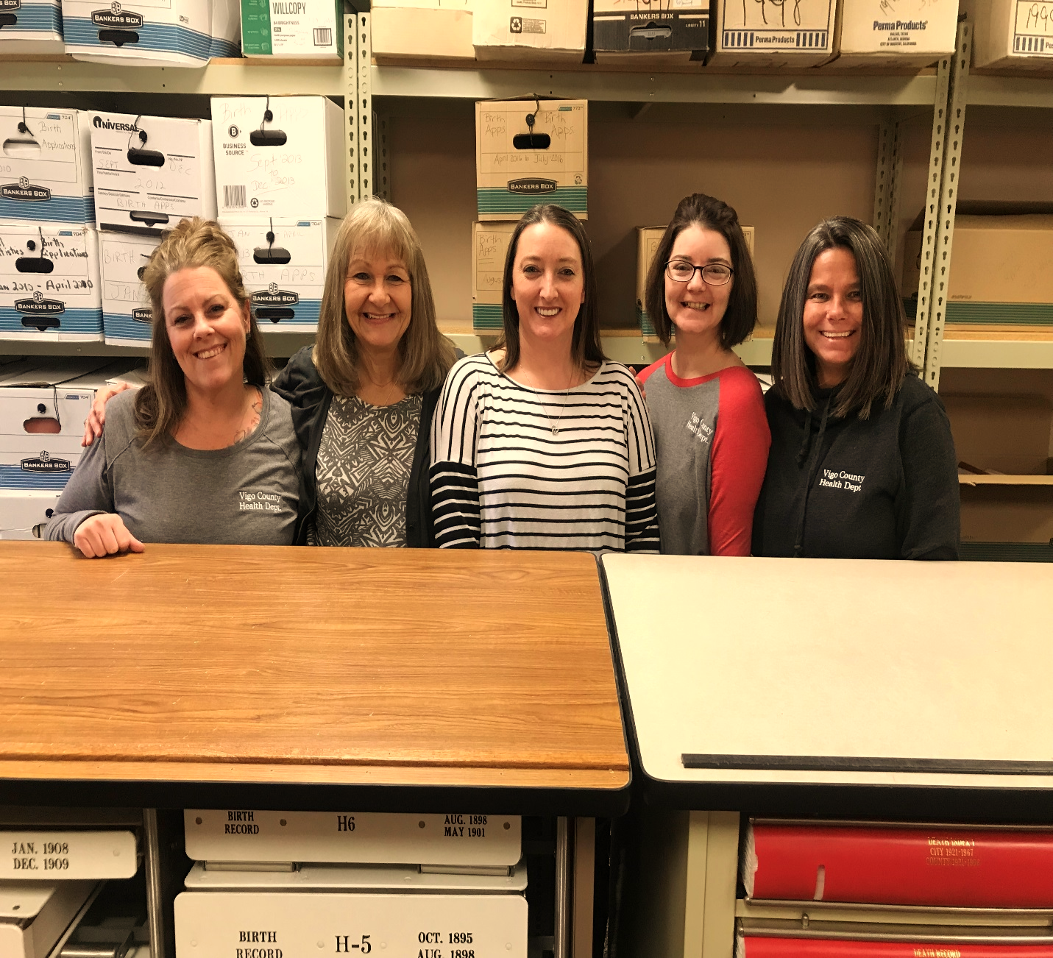
L to R: Brandie Draser, Cheryl Clements, Brooke Foltz, Jessica Kiger, Loretta Nicoson

THE VITAL RECORDS DIVISION’S OBJECTIVE IS TWO-FOLD:

- Carry out uniform procedures
- Maintain and protect the integrity of the Vital Records Systems



THE DIVISION HAS THE RESPONSIBILITY TO:
- Maintain a system that accurately records all births, deaths and fetal deaths
- Efficiently issue certified copies of records
- Issue provisional notification of death-burial transit permits
- Process paternities when they come to us from the courts
- Type and process paternities when people schedule appointments to come in to our office
- Type affidavits of amendment and schedule appointments for people to make corrections to their birth record
- Work with funeral homes in filing death certificates
- Verify birth records for the Military, Social Security and Division of Family and Children
- Assist citizens who wish to inspect permanent birth and death records
- Assist customers in doing genealogy

VITAL STATISTICS ANNUAL REPORT 2018

BIRTHS REPORTED
In-Wedlock 1,045
Out-of-Wedlock 1,029
Total Births 2,074

HOME BIRTHS 2
STILLBIRTHS 19

DEATHS REPORTED 1,475

CORONER CASES 209

CORRECTIONS PROCESSED
Affidavit of Amendments 40
Adoption 251
Paternity Affidavit 87
Legal Name Changes 14
CODP 32
Total Corrections 424

BIRTH CERTIFICATES ISSUED 9,505

DEATH CERTIFICATES ISSUED 9,666

CERTIFICATES ISSUED FREE 437
GENEALOGY SEARCHES 95

Notifications of Death (in County) 7071
Notifications of Death (out of County) zero

GENERAL HEALTH FUND $169,319.50
CORONER’S TRAINING AND EDUCATION FUND $19,458.00
TOTAL CASH RECEIVED $188,777.50

2018 INDIANA VITAL RECORDS ASSOCIATION CONFERENCES
IVRA proudly holds two separate conference opportunities each year. A Spring and Fall Conference is available to all IVRA members and nonmembers. Generally, at conference new speakers are introduced, a business meeting is held, new members of IVRA are met, and a whole lot is learned! This is a great networking opportunity for Indiana Registrars.
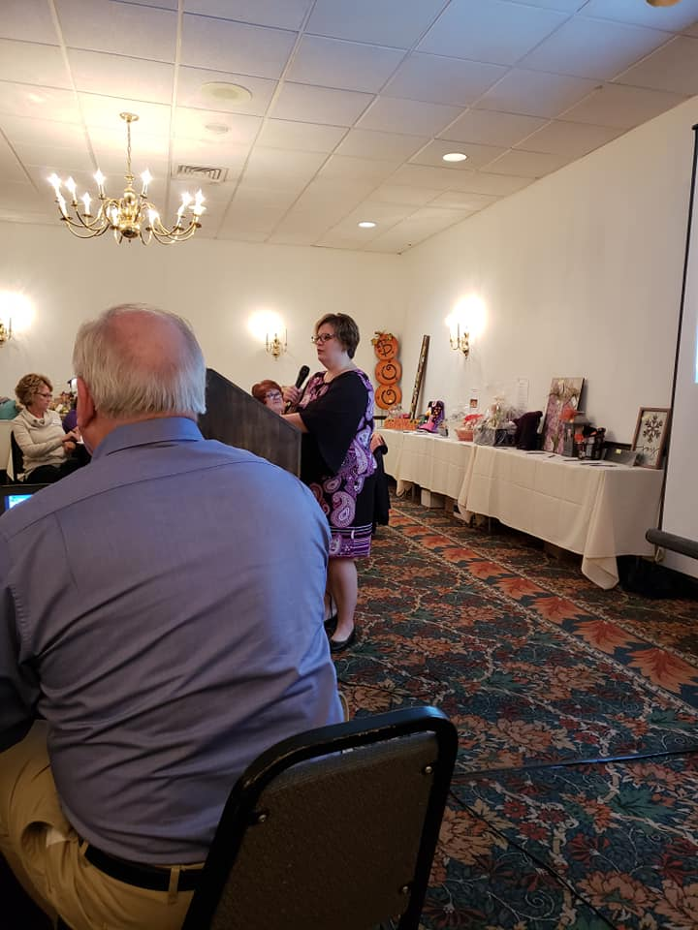

The Indiana Vital Records Association is an organization whose mission is to provide a forum for collaboration, cooperation, and communication through membership. The Association strives to accurately register and record, in a timely manner, the Vital Events of Indiana. The integrity of Vital Statistics is maintained through consistent procedures achieved through education, support and training to best serve its members and the public.

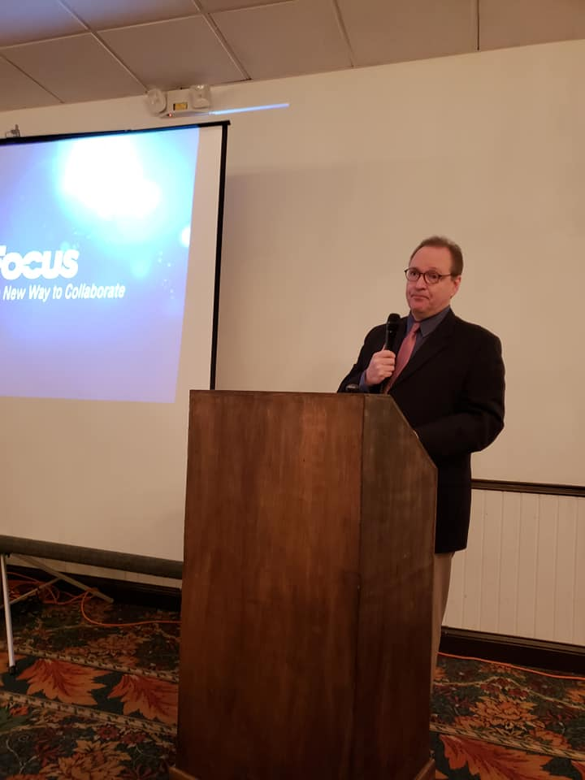

VECTOR CONTROL DIVISION
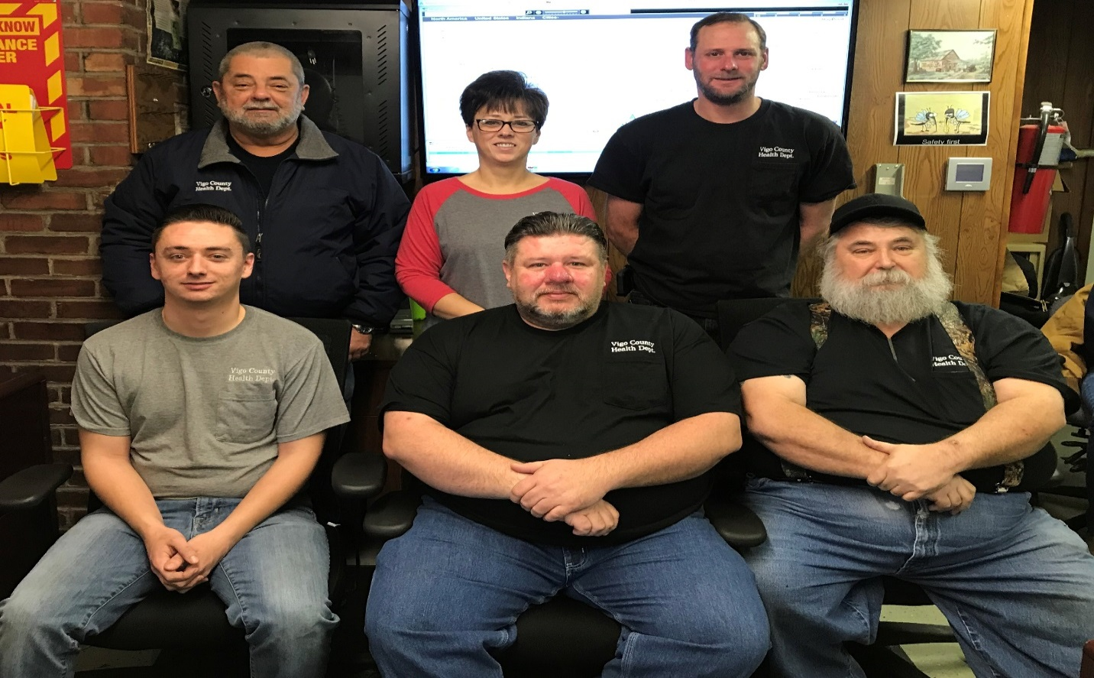
L to R front row: Logan Edwards, Warren Sweitzer and Tony Grayless
L to R back row: Mike Grayless, Kim Edwards, and David Higgins

The primary goal of the Vector Control Division is to reduce the risk of disease and death from pathogens carried by animals and/or vectors. The Vector Control Division also repairs and maintains all Health Department vehicles and spraying equipment.
A “vector” is an agent capable of transmitting a pathogen from one organism to another. (i.e. mosquito, rodent). The Vector Control Division devotes its time primarily to:
Vector control
West Nile surveillance
Dead animal removal
Fleet maintenance and repairs

MOSQUITO CONTROL
The spraying for adult mosquitoes in Vigo County was as diligent as the weather would allow in 2018. The adulticiding program consists of five ½ ton pickup trucks and four ATVs (equipped with ultra-low volume cold aerosol fog machines) to spray insecticides throughout the county, as well as the city of Terre Haute, for the control of adult mosquitoes. The ATV mounted ULV makes most sites accessible. All nine ultra low volume-fogging machines must be certified for droplet size and calibrated for flow rate prior to each spraying season. Calibration is monitored daily throughout the spraying season. Adult mosquito control is accomplished using three insecticides, Bio-Mist 4+12, Kontrol 4X4 and Aqua Anvil.
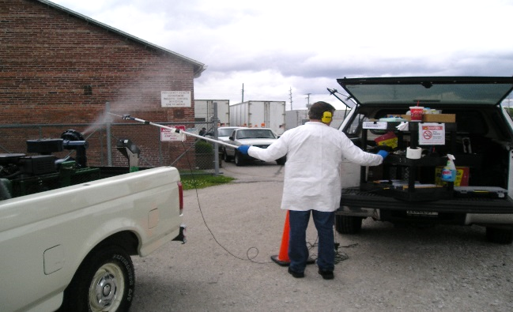 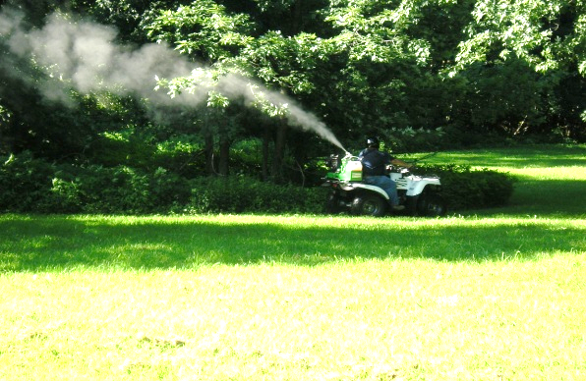 Chris Novak of Clarke Mosquito Control testing equipment Vector Control Specialist Tony Grayless

All ULV units are fitted with GPS compatible “Smart Flow” systems. This enables Vector Control staff to preset and record calibration, time of spraying, flow rate and vehicle speed.
Vector Control staff prepares and updates 26 maps that are 40-45 miles of County and city roads. The 26 maps show the areas to treat and also areas that we do not treat, which we consider no spray zones. Some of the areas that are considered no spray zones might be areas with organic gardens, beekeepers, large bodies of water or persons who have requested no spraying be done in the area they live, either for health or personal reasons. The 26 maps are treated weekly, biweekly or monthly depending on adult mosquito population and weather conditions.

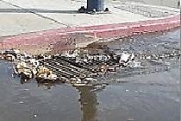
Vector Control employees spend an extended amount of time treating stagnant water for mosquito larvae. Several brands of insecticide targeting several species are employed to kill the larvae. One type of insecticide (Golden bear) can last for seven days in stagnant low area water, covering the surface of the water denying the mosquito larvae access to air. All “catch basins” or dry wells are treated with Altosid briquettes and Bactimas briquettes which lasts 30 or 150 days. Altosid Briquettes inhibit the growth of the larvae preventing them from becoming adults. Catch basins have been identified as one of many ideal habitats for the Vector (Culex pipiens), a mosquito, notoriously known for the transmission of West Nile. Culex mosquito larvae love the stagnant dirty water left behind from rain that doesn't soak into the ground but runs off into catch basins, retention ponds, and roadside ditches.
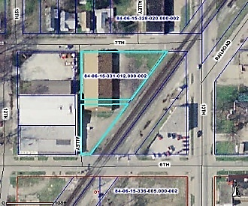
In 2018, approximately 1,410 catch basins were treated. That number continues to increase due to community growth. Parking lots and subdivisions will install retention ponds and or catch basins to contain water runoff. Catch basins and larvaciding sites are mapped out using the County’s GIS system. Larvae samples are examined for identification to insure proper treatment.
Amount and types of insecticide used in Vigo County to control adult mosquitoes and larvae
 | INSECTICIDE | AMOUNT USED
55 Gallon Drum | Biomist 4 + 12 | 11 Drums
55 Gallon Drum | Kontrol | 18 Drums
55 Gallon Drum | Aqua Anvil | 12.5 Drums
220 Per Case | Altosid Briquettes (150 Day) | 7 Cases
100 Per Case | Bactimas Briquettes | 11 Cases
3/4 Gallon | Talstar P | 1/4 gallon
55 Gallon Drum | Golden Bear | 30 Gallons

WEST NILE VIRUS SURVEILLANCE
We use two different types of light traps. One type of light trap (CDC –CO2-Baited trap) uses dry ice or an attractant called “octonol” which simulates the exhaled respiratory gases of birds or mammals. The other is a gravid trap that uses alfalfa pellets mixed with water. The fermentation of these pellets releases an odor, similar to a livestock barn, and creates dirty, stagnant water that attracts gravid culex mosquitoes.
Light traps were set out at numerous locations throughout Vigo County with 2,930 mosquitoes being collected between June and October 2018. Once the mosquitoes are collected they are separated into groups ranging in number from 5 to 100 and are then labeled as pools of mosquitoes, which are sent to the Indiana State Department of Health for West Nile testing. A total of 83 pools were sent in for testing in 2018. The Indiana State Department of Health reported 30 positive pools for Vigo County. Vector control specialists will continue to set, maintain and collect mosquito pools for ISDH West Nile Virus testing in the upcoming year.
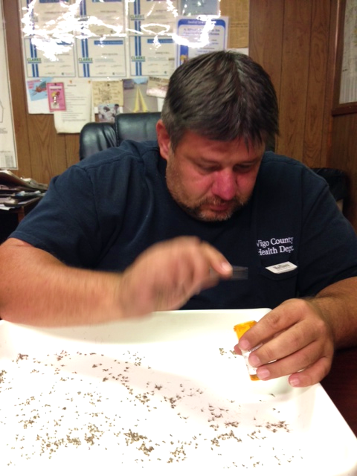 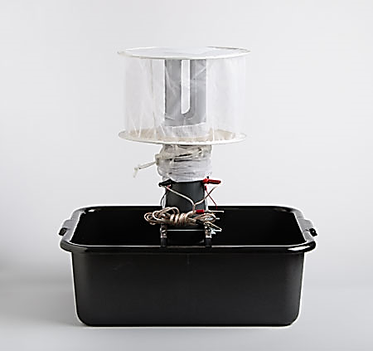 Warren Sweitzer sorting mosquito samples. Gravid Trap

TOTAL MOSQUITOS COLLECTED

PRECIPITATION AMOUNTS

AVERAGE TEMPERATURES

MOSQUITO BORNE DISEASE PREVENTION ACTIVITIES IN 2018:

- Distributed 5,600 “Skeeter Beater” coloring books to pre-school through 3rd grade elementary students on preventing/ identifying prime breeding areas for mosquitoes.
- Worked with Home Owners (high grass, weeds, pools, fish ponds, standing water).
- Sent out Notice to Abate letters to all Vigo County cemetery caretakers.
- Worked with Terre Haute Street Department to remove standing water from alleys.
- Participated in Clean up Terre Haute program in May 2018.
- Continued to monitor home owners, tire retailers and salvage yards to ensure compliance with the Tire Storage Ordinance.
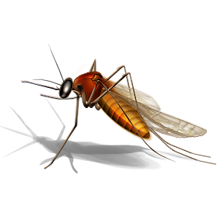
2019 MOSQUITO & LARVAE CONTROL STRATEGIES
- Intensify local culex and aedes mosquito larval control to prevent the emergence of adult mosquitoes that feed on birds and contribute to the virus amplification transmission cycle.

- Continue active West Nile surveillance to determine the presence of new or expanding West Nile transmission. (Light traps-Adult mosquito testing)

- Reinforce public education and outreach programs to reduce mosquito- breeding sites around homes.

- Educate on personal protective measures (long sleeves, insect repellent) with the use of the media (TV, radio and newspapers)

- Implement local mosquito control to reduce the number of virus infected mosquitoes, thus reducing the immediate risk to humans.

- Monitor adult and larval mosquito control efforts to ensure that the local programs are effectively reducing mosquito densities and virus infection rates.

- Conduct inspections of local tire retailers and junkyards for tire storage ordinance compliance.

RODENTS
Rodents (i.e. rats, mice) are another source of disease transmission. Rodents must have adequate food, shelter, and water in order to survive. For these reasons, a large majority of rodent complaints are located within the city of Terre Haute.
A vector control specialist investigates complaints about rodents and proceeds to make recommendations to the property owner on findings and rodent control (i.e. removal of debris, animal feces). In some cases, the vector control specialist may set out bait and remove dead rodents, but the majority of the extermination is usually the responsibility of the property owner. A vector control specialist will continue to make follow up inspections to insure the property owner is correctly handling the problem.
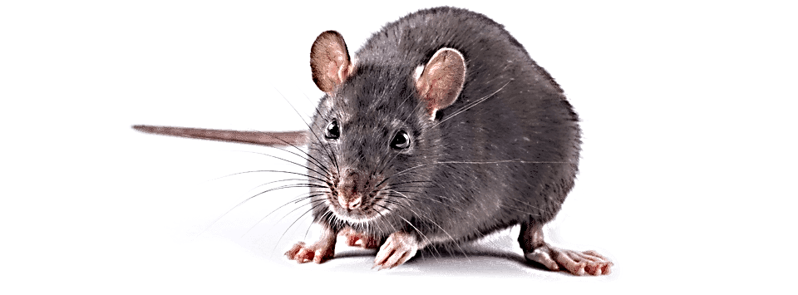
RABIES
In 2018 Vector Control staff sent 14 bats and one squirrel to the ISDH for rabies testing. All tests results were negative for rabies virus. Night surveillance was performed by Vector Control staff at three homes in Terre Haute to assist the homeowners in bat proofing their homes.
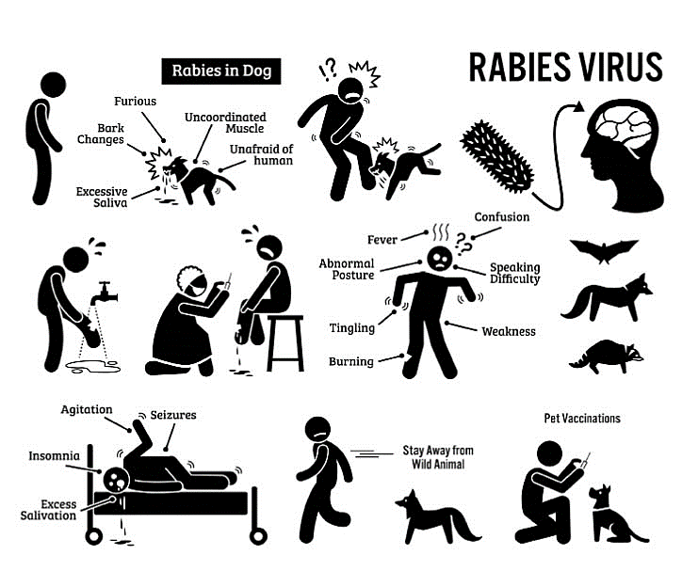

REMOVAL OF DECEASED ANIMALS
In 2018 a total of 615 deceased animals were taken to the county landfill. 548 were removed from private properties as well as city and county roadways. An additional 67 were removed from the Terre Haute Humane Shelter.

VEHICLE MAINTENANCE

During the winter months the Vector Control Division is busy with repairing, cleaning and inspection of all vehicles and equipment. All ULV spray units must be cleaned and broken down during the winter months, checked, repaired and parts replaced as needed. Along with routine maintenance, all trucks and cars are thoroughly inspected and repaired. All Health Department vehicles and equipment have routine maintenance throughout the year.

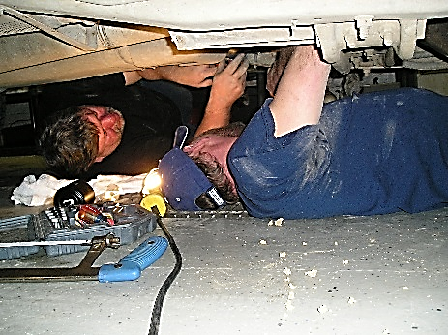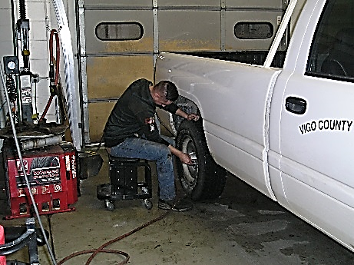
David Higgins and Warren Sweitzer repairing a truck. Logan Edwards doing vehicle repair

TIRE CLEAN-UP PROGRAM
In 2018 Vigo County Health Department employees removed discarded tires from the alleys and streets of Terre Haute and surrounding communities. A total of 3,742 tires, filling four semi-trailers, were collected. Residents that had tires stored outside were given information on our Tire Storage Ordinance informing them that the tires must be stored inside or removed from the property.

NURSING DIVISION
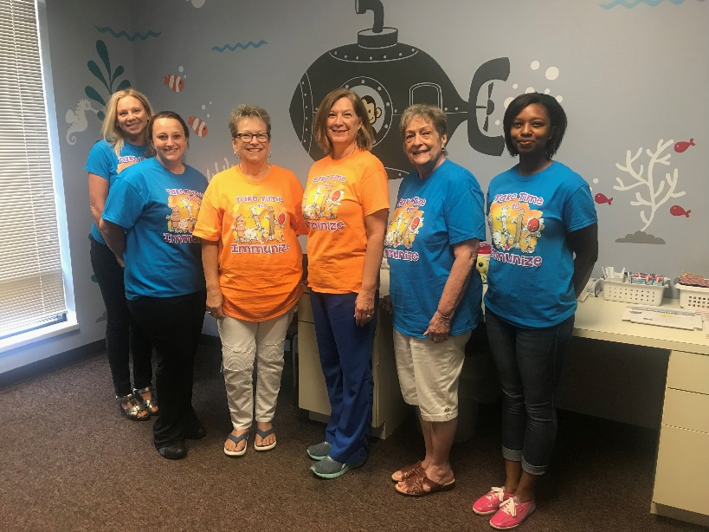
L to R: Rhiannon Moore, Chelsea Willis, Teresa Bechtel, Twila Spidel, Dolly Moss and Andrea Craft.
The Vigo County Health Department (VCHD) Clinic is staffed by three full-time Registered Nurses, a full-time Secretary, an Immunization Registry Clerk, and a full-time Insurance and Billing Clerk. In addition, a pediatrician, Dr. Catherine Brown staffed our weekly Well Child Clinics. The Health Department Clinic provided services to both children and adults for a nominal fee or free of charge. In 2018, there were 5,008 client visits to the clinic.

ADULT VACCINE PROGRAM/ADULT STAY WELL PHYSICALS
The Adult Stay Well Program was continued by Dr. Brown who provided adult physicals which included college students, daycare employees, and foster care parents for a nominal fee. The VCHD is enrolled in the Vaccines for Adults program to provide immunizations for adults with no insurance or insurance that does not cover vaccines.

WELL CHILD PROGRAM/ SPORTS - KINDERGARTEN PHYSICALS
The Well Child Program serves children from birth to 18 years of age. In 2018 the VCHD Clinic continued our weekly Well Child Clinics on Wednesday’s. Dr. Brown provided well child physicals, sports physicals, kindergarten physicals, and Head Start Physicals for a nominal fee.
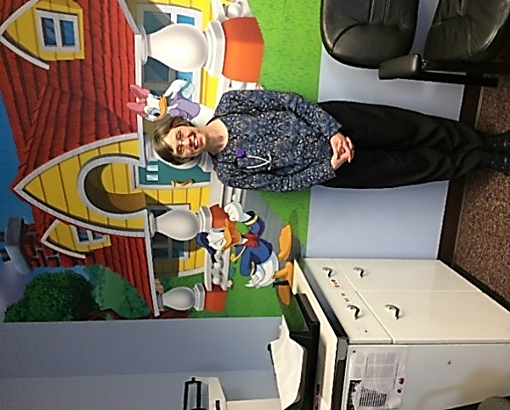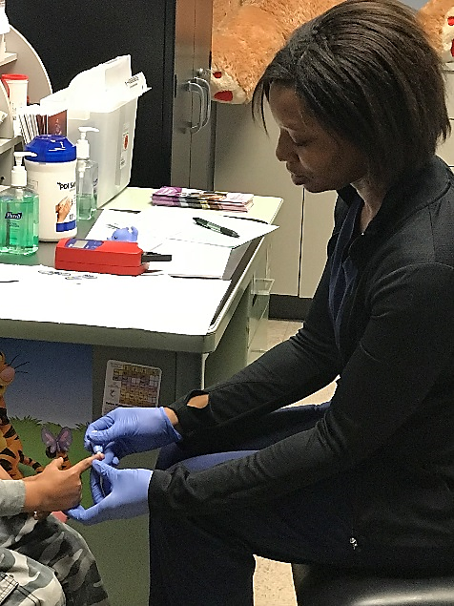
Dr. Brown Andrea Craft RN performing a lead screening

LEAD SCREENING
In 2018, approximately 128 children were screened for lead poisoning by the Vigo County Health Department Clinic. We held many lead screening outreach clinics throughout the county such as Head Start, Early Head Start, and ISU Early Childhood Center. Lead poisoning case management and environmental lead risk assessment consists of patient cases that are over the level of 10 mcg/dl for venous blood lead levels. The Lead Case Manager had 17 lead cases >10mcg/dl and 10 home investigations.

EPIDEMIOLOGY AND COMMUNICABLE DISEASE
Indiana Code 16-41-2-1 requires local health departments to investigate and report communicable diseases listed in the Indiana State Department of Health Communicable Disease Reporting Rule. Once the investigations are completed, they are entered into the computerized data base known as the Indiana National Electronic Disease Surveillance System (I-NEDSS). VCHC Clinic nurses investigated and reported 325 confirmed communicable disease cases in 2018. Chronic Hep C is still the most prevalent disease.
 | totals 2017 | Totals 2018
Animal Bites | 146 | 167
Campylobacteriosis | 19 | 14
Carbapenemase-producing Carbapenemase-resistant e\Enterobacteriaceae (CRE) | 1 | 36
Chicken Pox | 5 | 2
Hepatitis C | 110 | 182
Hepatitis A | 1 | 2
Histoplasmosis | 4 | 4
Lyme Disease | 5 | 1
Streptococcus A | 1 | 5
Streptococcus Pneumoniae | 14 | 16
*This table includes cases that might not be determined. Investigation must be initiated in order to make a final determination. Not publicly reported if total number of cases is less than 5.

TUBERCULOSIS CASE MANAGEMENT AND TESTING
Tuberculosis (TB) control and case management by Local Health Departments is a mandated task under the Indiana Code 410 IAC 1-2.3-106. This includes investigating positive skin tests, collection of sputum samples for evaluation by the ISDH lab, providing medications for both active and latent TB cases, home visits for medication administration, evaluation and testing for contacts of the infected patient, communication with the patient’s physician, and patient education. In 2018, 0 active TB cases, 1 suspected, and 18 latent TB cases were managed by the VCHD Clinic. In addition, the VCHD Clinic provided TB skin testing on a walk in basis for the community for a nominal charge. 1,103 TB skin tests were administered in 2018.

VACCINES FOR CHILDREN PROGRAM/PRIVATE PAY VACCINES

The VCHD Clinic is a provider enrolled in the Vaccines for Children program and provided childhood immunizations to those who qualified. With some of the pediatricians in and around town not carrying immunizations the VCHD helped immunize those children. Most major insurances were accepted at the VCHD with the help of Vaxcare.

ADULT VACCINE PROGRAM/ADULT STAY WELL PHYSICALS
The Adult Stay Well Program was continued by Dr. Brown who provided adult physicals which included college students, daycare employees, and foster care parents for a nominal fee. The VCHD is enrolled in the Vaccines for Adults program to provide immunizations for adults with no insurance or insurance that does not cover vaccines.

COMMUNITY INVOLVEMENT
Immunizations are an important part of what the nurses at the Vigo County Health Department do on a daily basis. Approximately 193 flu vaccines were given to Vigo County Employees in the fall of 2018. The VCHD nurses serve at clinical preceptors for nursing students from Indiana State University and Saint Mary of the Woods College. The Health Department nurses, Twyla Spidel RN, Chelsea Willis RN, and Andrea Craft RN, sit on the Vigo County Immunization Task Force; which meets quarterly with other medical professionals, school nurses, and childhood development members to collaborate and create new ways to increase immunization rates for Vigo County.
Andrea Craft RN | Twyla Spidel RN | Chelsea willis RN
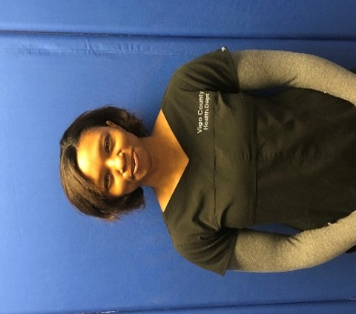 | 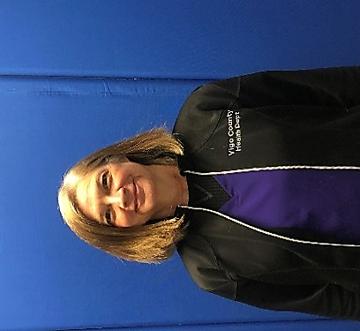 | 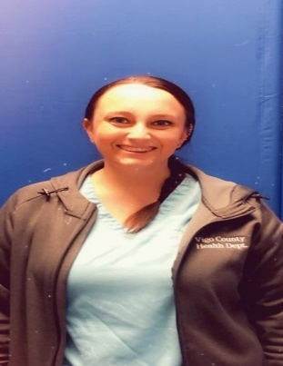

EDUCATION
The public health nurses attended numerous training and educational courses throughout the year. Immunization Task Force, World TB Conference, Preparedness Training, Immunization A-Z, Public Health Nurse Conference, Lead Training, National Immunization Conference, Tri State TB Conference, and Labor of Love. There were also in-house trainings done in the VCHD Clinic. Education is an important aspect to evidence based care.
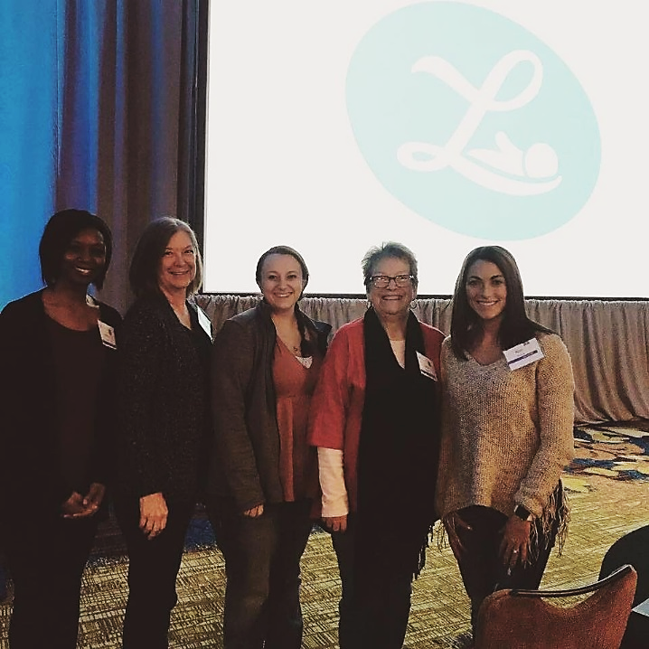
Labor Of Love Conference in Indianapolis, Indiana
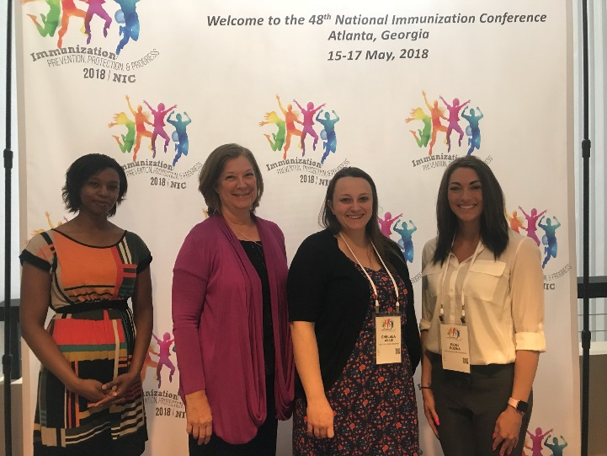
National Immunization Conference in Atlanta, Georgia

INDIANA STATE DEPARTMENT OF HEALTH

IMMUNIZATION GRANT

A grant was awarded to the Vigo County Health Department Nursing Division by the Indiana State Immunization Division in 2018 for $75,407. Funds from this grant were used in various ways to increase immunization rates and promote services offered at the health department clinic. The VCHD Clinic were able to purchase various supplies and equipment for the health department clinic. Since the immunization grant was started in 2014, immunization rates in Vigo County have increased from 28% to 65% in 2017. Immunization rates for 2018 were not yet available. The grant funded the VCHD Clinics ability to accept most private insurances. 496 private insurance clients were administered vaccines in 2018.
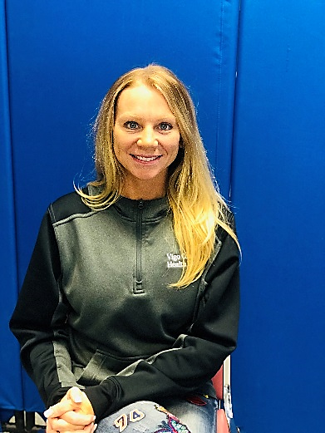
RHIANNON MOORE, INSURANCE BILLING SPECIALIST

HEALTH EDUCATION

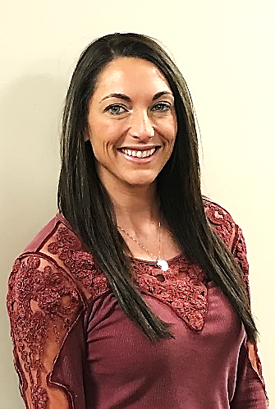

Roni Rozina, Health Educator/Media Coordinator

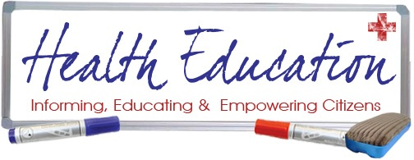

Health Education is the process of assisting individuals and groups to make informed decisions and build skills on matters affecting personal, family and community health. Health Education provides information about awareness and prevention with the goal of providing Vigo County Citizens with the opportunity to their healthiest.

PRESENTATIONS
Presentations offer a comprehensive look at today’s public health issues that are of concern. Some presentations are multi-faceted, such as an overview of the Health Department and its role in public health in Vigo County while others can be an in-depth look into issues such as bedbugs, influenza, or tobacco use in our community. This involvement offers the public the opportunity to learn about their health and well-being, ask questions, and become familiar with the Health Department. The Vigo County Health Department works collaboratively with many community partners which include but are not limited to; the Vigo County School Corporation, Hamilton Center, Vigo County Head Start, and Indiana State University.
The following is a brief list of programs & presentations conducted:

- VC Employee CPR Program
- IPEC Presentation (Hepatitis A/ Needle Exchange)
- Health Department Education at Health Careers Exploration Camp
- Hand Washing & Food Safety at West Vigo Middle School

SOCIAL MEDIA
An evolving key piece of Health Education is our Social Media presence. We are very excited to be a part of Facebook, Twitter, LinkedIn, YouTube, Pinterest, and Instagram! With the growing usage of social media it is crucial to use that to our advantage in reaching the public in every way possible for education and information. The use of social media in emergency situations such as an outbreak or natural disaster is also one of our main reasons to jump on board. Our goal is to provide the most accurate, up-to-date information as quickly as possible to our community.



MEDIA PARTERNSHIPS
Working with the media is an extremely important component of Health Education. In order to ensure the residents of Vigo County receive the most accurate and up to date health information, the Vigo County Health Department has developed an excellent relationship with the media. The Health Educator/Media Coordinator works diligently with media outlets to compose important health messages in order to promote, provide, and protect the citizens of Vigo County and the surrounding areas. The following health topics were covered in the media:

- Influenza
- Cold Weather Safety
- Vital Records
- Tire Amnesty Program
- Hepatitis A
- Vaccinations for Adults
- Health Department Services
- Mosquitos Prevention tips
- West Nile Virus Prevention
- Well Child Night Clinic
- Fogging Schedule
- Adoption Laws
- Heat Safety
- Homecoming Food Vendors
- Immunizations for Children
- Board of Health Meetings
- Global Handwashing
- Lead Prevention Week
- Food Safety/Leftovers
- Labor of Love Summit
- Leftover Food Safety
- Turkey Thawing Tips
- E.Coli Outbreak
- Halloween Safety
- Toys for Tots
- Food Permits/Mobile Units
- And many more!
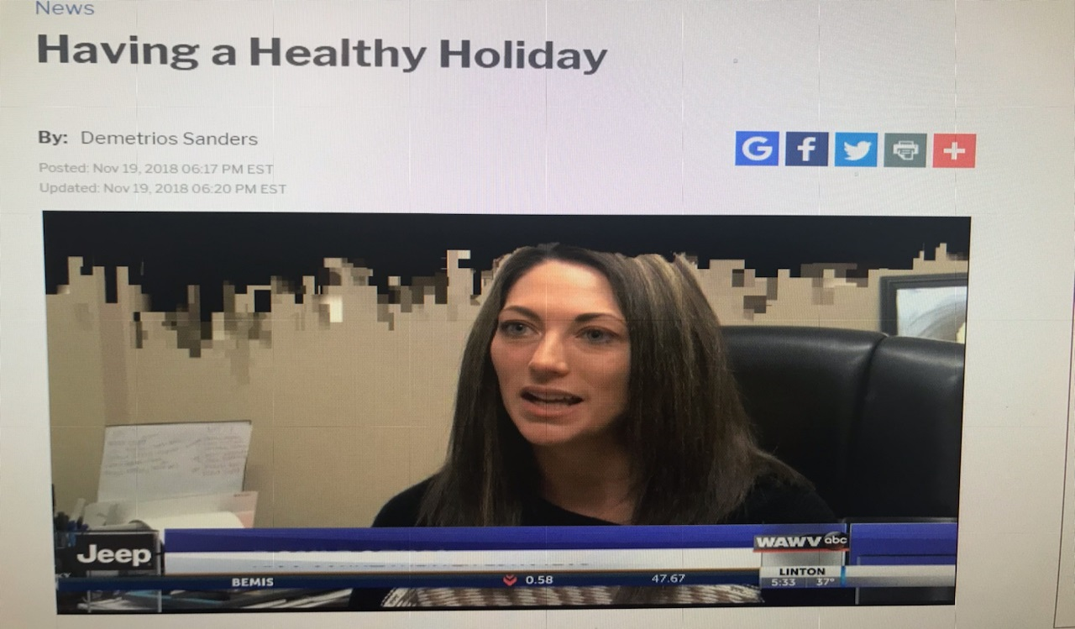
COMMUNITY INVOLVEMENT
Health Education and Media Coordination works collaboratively with hundreds of Vigo County members in order to provide fast, reliable, and educational information to our citizens.

- Tobacco Prevention Cessation Coalition
- Preparedness Planning Coalition
- Environmental Coalition
- Health Education Advisory
- Vigo County Jail
- Crisis Pregnancy Center
- Lamar Outdoor Advertising
- Cummins Behavioral Health
- CODA
- Toys for Tots
- Office of the Indiana Attorney General
- Head Start Advisory
- Chances and Services for Youth
- Drug Free Vigo County
- Vigo County School Corporation
- Indiana State University
- Lighthouse Mission
- United Way of the Wabash Valley
- Better Health Wabash Valley
- ISDH Harm Reduction

HEALTH FAIRS
Health fairs are a great way to promote health awareness and encourage participants to take responsibility for their health and provide valuable information. Health fairs allow health department employees the opportunity to meet with the public and discuss their specific concerns in locations that are convenient and easily accessible. This year, Vigo County Health Department participated in the following health fairs:

Alliance for a Healthier Indiana
Wabash Valley Health Clinic Health Fair
Terre Haute Community Health Fair

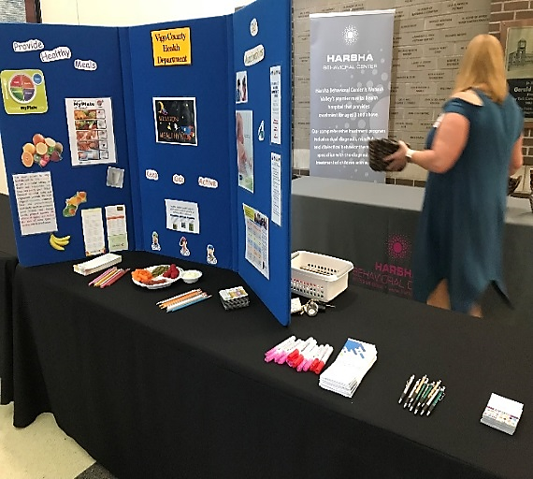
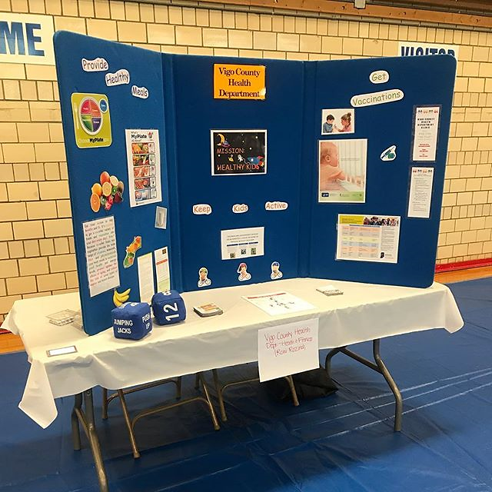

ENVIRONMENTAL HEALTH DIVISION

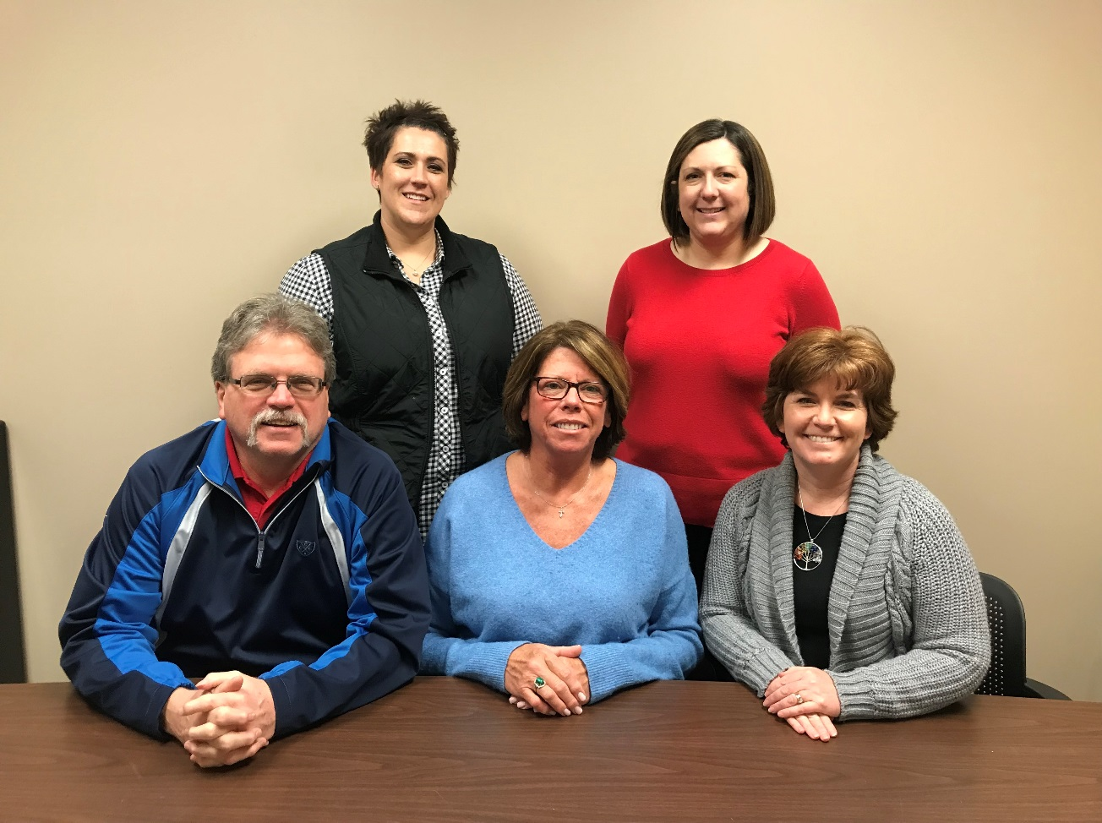
L to R front row: Steve Thompson, Theresa Jackson and Travella Myers
L to R back row: Mandy Bales and Marci Shaw

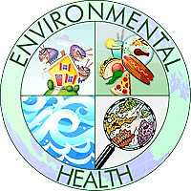
Environmental Health Division protects public health and the environment by ensuring conformance with State laws and County ordinances pertaining to a wide variety of environmental health programs. Much of this work is accomplished by performing routine inspections and investigations and taking enforcement action when warranted. The Environmental Health Division also interacts with various federal, state, regional, and local governmental agencies associated with environmental health programs.

FOOD SAFETY PROGRAM
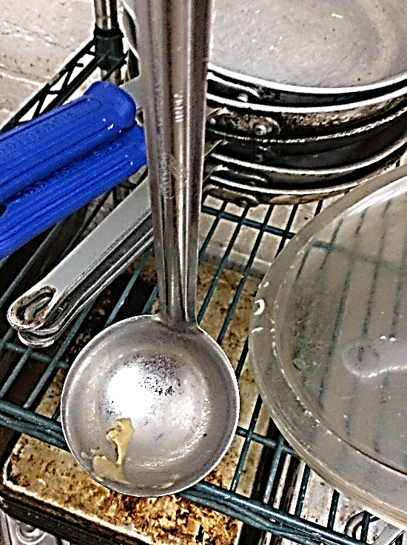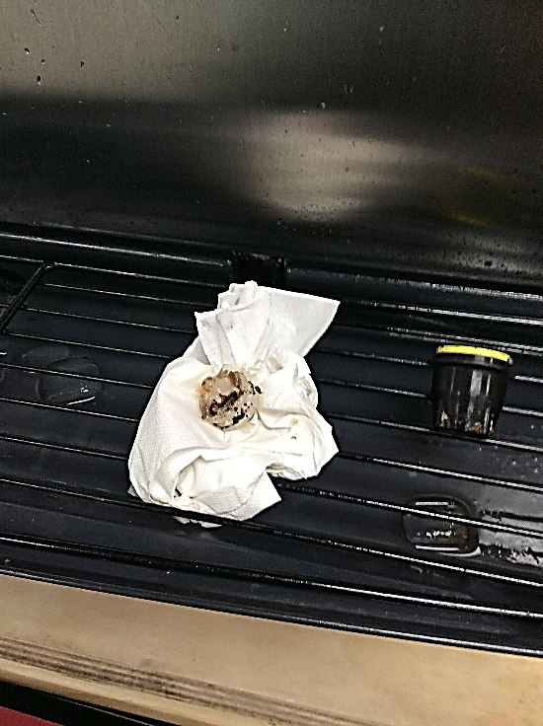
Typical violations found in restaurants

The Food Safety Program involves the planning of new and remodeled retail food establishments, planning of fairs and festivals in Vigo County, and the licensing and inspecting of all retail food establishments within Vigo County. We work closely with the state department of health on any food recalls and food borne illnesses.
By promoting food safety education and fostering understanding, communication, and cooperation among regulators, industry and consumers, VCHD seeks to provide the best public health and consumer protection in an expeditious and cost-effective manner.

Permits Printed
- 517 Retail food establishments
- 94 Temporary food stands
- 20 Mobile units
- 13 Farmer’s Markets

Inspections Conducted:
- 805 routine inspections
- 10 follow-up inspections
- 13 plan reviews
- 47 opening inspections

WASTEWATER MANAGEMENT PROGRAM

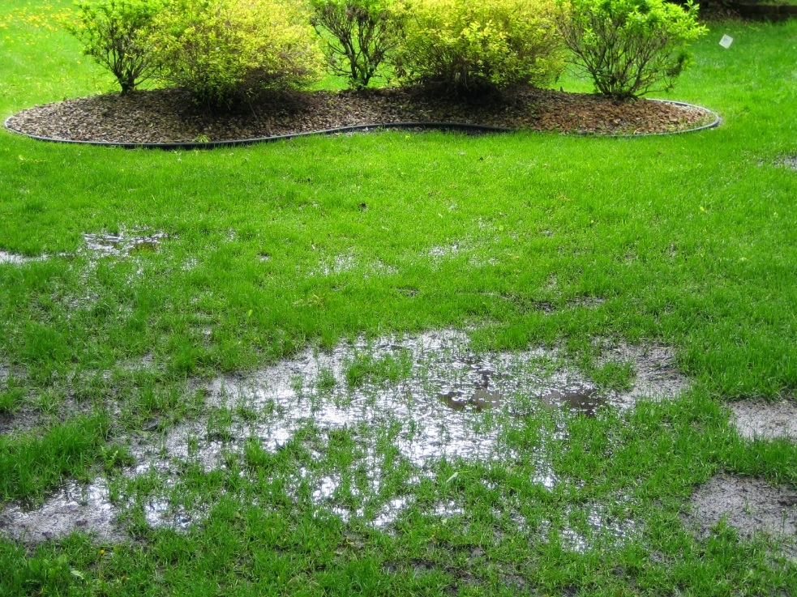
Failing Septic System

An on-site system is one which treats the sewage in a septic tank so that most of the sewage becomes effluent and is disposed of in an area close to the house or buildings. An example of an on-site disposal system consists of a septic tank and leach drains.
The planning, installation, and repair of on-site sewage disposal systems must be reviewed and inspected by one of our full-time environmental health specialist. This includes the reviewing of soil scientist reports, drawing of installed systems for department records, and giving recommendations for proposed subdivisions.
A total of:
- 91 Septic Permits
- 38 Subdivisions
- 366 Improvement Location Permits

RECREATIONAL WATER PROGRAM

- 125 Regular inspections were performed
- 28 Follow-up inspections
- 21 Closings
- 2 Openings
Waters used for recreational purposes are subject to a variety of environmental influences which can affect the health and/or safety of individuals using those waters. According to a recent report from the Centers for Disease Control and Prevention, between 2000 and 2014, researchers said, 493 disease outbreaks were reported from public swimming holes, such as hotels and hot tubs. Thirty-two percent of those outbreaks — defined as when at least two people reported similar illnesses — occurred in hotels
The recreational water program includes the inspection and review of bacteriological reports of swimming and wading pools, spas, therapy pools, and public access beaches. The inspection entails an evaluation of the pool area, water quality, safety equipment, and mechanical room.
The goals of these programs are to minimize safety hazards, reduce the potential for disease transmission and assure that waters used for recreational purposes are operated and maintained in compliance with the applicable ordinances.
BODY ART SAFETY PROGRAM
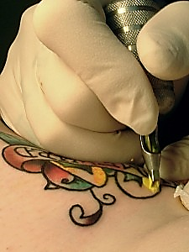
The use of improperly sanitized needles and instruments for invasive procedures on the human body and/or procedures being completed by inadequately trained individuals can contribute to the spread of communicable diseases and/or cause permanent injury.
Through the Body Art Safety program the Environmental Health Specialist works to ensure the safe and proper operation of the licensed body art establishments in Vigo County. We educate operators, evaluate plan reviews, and perform opening inspections on new or remodeled body art establishments. We also ensure general safety and sanitation standards, and proper disposal methods of infectious waste.
The Artist licensing program ensures the individuals that are performing the body art are knowledgeable and competent.

- 13 Body Art establishments licensed
- 8 Routine inspections
- 6 Opening inspection
- 35 Artist License

LEAD POISONING PREVENTION PROGRAM
Lead was a common ingredient in house paint where it acted as a pigment and increased durability. This was before the dangers of lead were known. Though banned for use in paint in the U.S. in 1978, millions of homes, schools, and businesses still have lead based paint on their walls, both inside and out. According to the Environmental Protection Agency, lead paint can be found in:
- 24% of homes built from 1960-1978
- 69% of homes built from 1940-1960
- 87% of homes built before 1940
If the paint is in good condition and has been painted over, it usually doesn’t pose a problem. But if the paint is peeling or has been disturbed by scraping, sanding, or burning, it can pose significant health risks to people especially young children.
The state of Indiana mandates the local health department to follow children with elevated blood lead levels of 10 μg or more and to provide services like parent education and blood testing of children with elevated blood lead levels of 5 μg/dL of blood or more. This includes educating the parents and conducting a risk assessment of the home.
We have two licensed Risk Assessors that address the lead risks in the homes of the children that have elevated blood lead levels. The Risk Assessors educate the families on proper cleaning procedures and mitigation choices when lead risks are identified. Additionally a Public Health Nurse follows that child until their blood lead levels drop below the mandated 10 μg level.

- 22 open cases
- 11 new cases
- 10 risk assessments
- 0 clearance exams

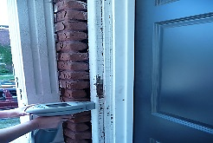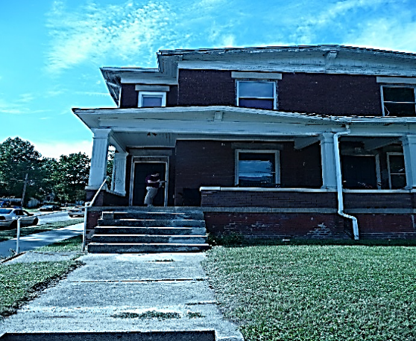

DRINKING WATER PROGRAM
Clean water is vital to our health, communities, and economy, it is a fundamental human need. Each person on Earth requires at least 20 to 50 liters of clean, safe water a day for drinking, cooking, and simply keeping themselves clean.
Tens of millions of people are seriously sickened by a host of water-related ailments—many of which are easily preventable.

The drinking water program includes the review of water sampling results from daycares, mobile home parks, and retail food establishments that utilize well water; education on proper care and shocking of wells, and guidance when flooding is an issue.


We have also been involved with the local water company when we have found homes with high levels of lead in their water due to old city water lines that had not been replaced.
PUBLIC HEALTH COMPLAINTS
Housing and property complaints filter through this program. Some of the problems addressed are: mold, rodents, roaches, animal feces, meth lab clean up, surfacing sewage, and human feces. We collaborate with other agencies such as Child Protective Services, Adult Protective Services, City and County Building Inspection, City Environmental, City and County law enforcement.

- 28 surfacing sewage complaints
- 7 unfit housing situations
- 5 animal feces complaints
- 37 bed bug complaints
- 25 mold complaints
- 21 Meth Lab letters

COMMUNITY INVOLVEMENT
TOYS FOR TOTS
In 2018 VC Health Department employees donated $2,000 for the Toys for Tots program.
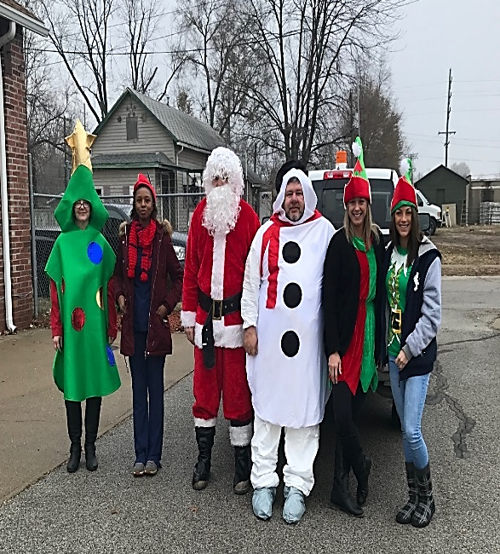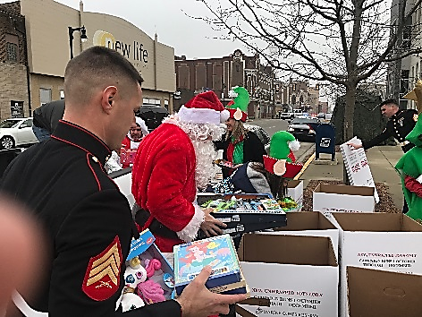
CASA TRUNK & TREAT
VIGO COUNTY HEALTH DEPARTMENT EMPLOYEES “HOBO JUNCTION”
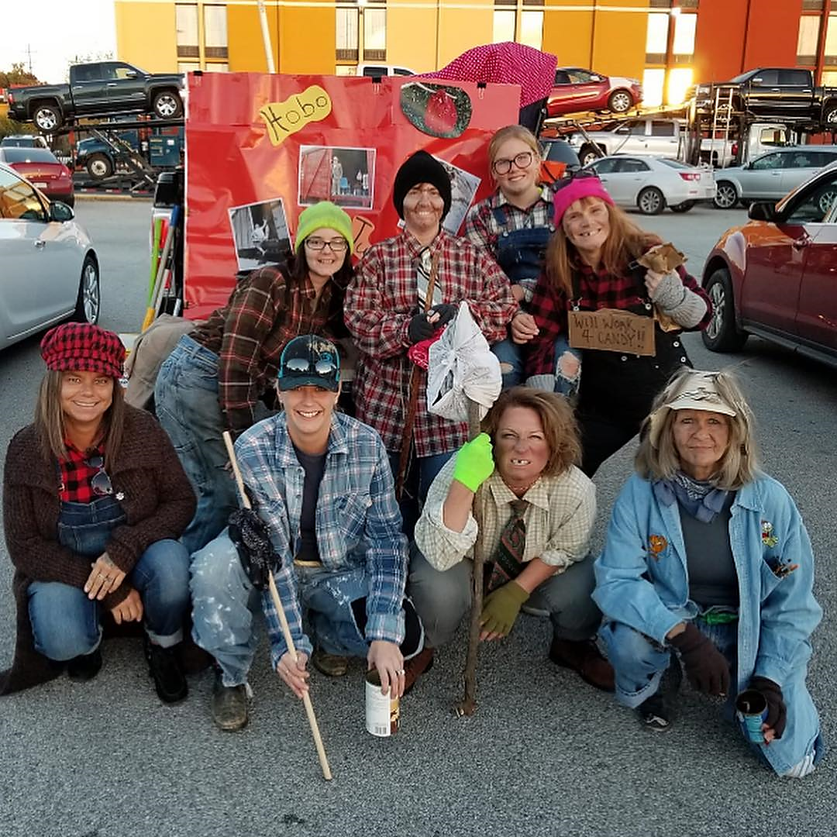
HEPATITIS A CLINICS
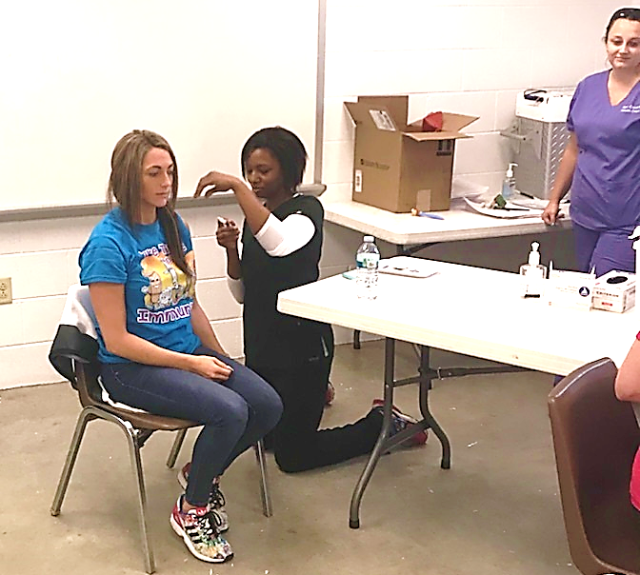
STUDENT INVOLVEMENT
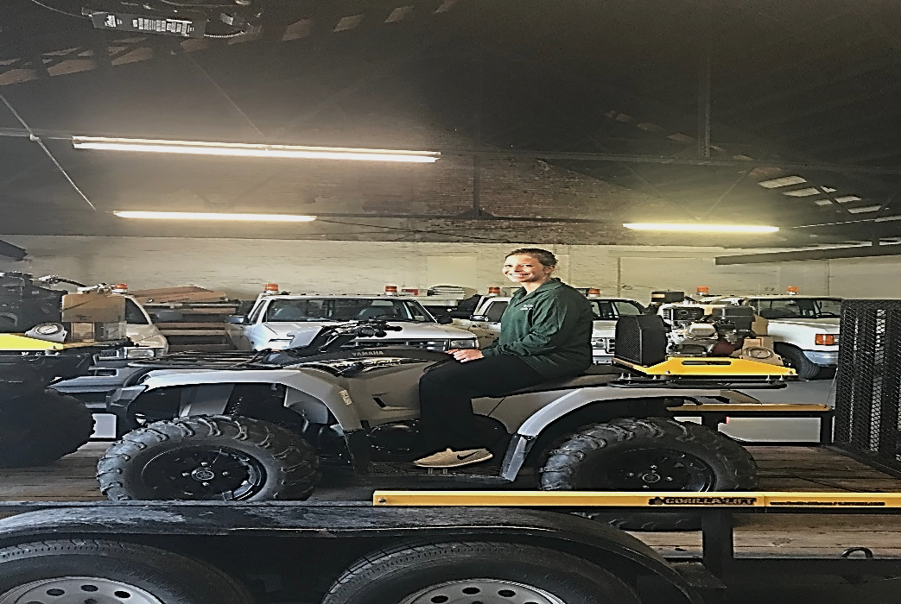
Nicole Niespodzian, Registered Nursing Student
Saint Mary of the Woods College

THE END

