VIGO COUNTY
HEALTH DEPARTMENT
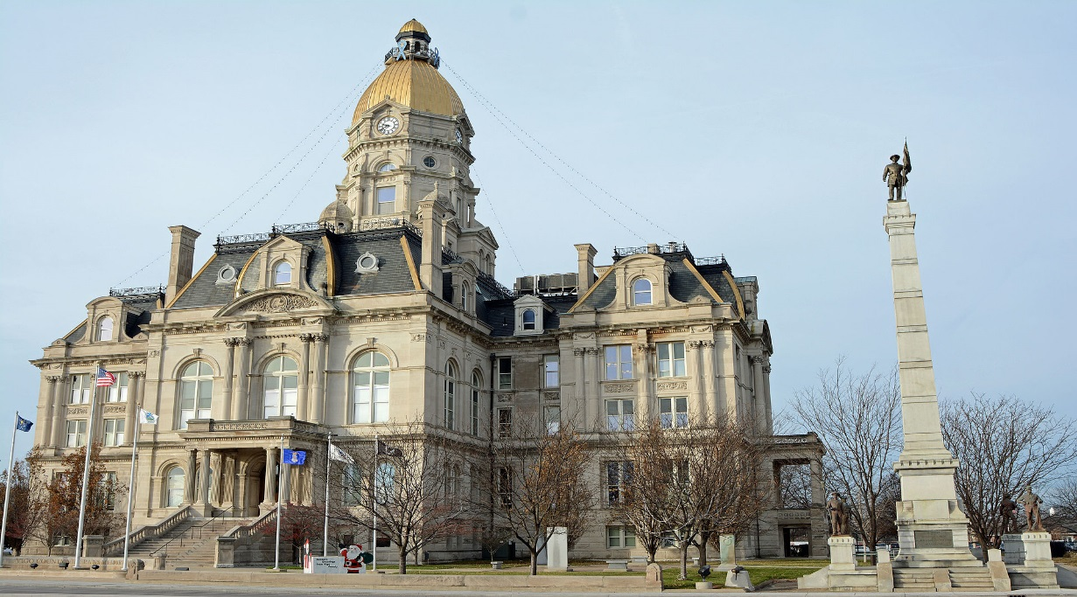
2019
ANNUAL REPORT

The Vigo County Health Department serves to promote, protect and provide for the well-being of the citizens in Vigo County

BOARD OF HEALTH

For almost 50 years, the Vigo County Health Department has provided the citizens of Vigo County with the very best public health services possible. Today, those services have expanded into areas our predecessors never imagined, challenging us to keep pace with the demands of an ever changing environment and population. The Vigo County Health Department has continued in the successful tradition established under the leadership of its Board of Health. Members of the Board of Health have roots in medicine, law, business, industry, labor and social services. Maintaining communication between the governing body and staff members has been instrumental in relating regulation and procedures that best serve the community. The Vigo County Board of Health is appointed by elected officials in order to represent the needs of the community. The Vigo County Board of County Commissioners appoint all seven members of the board, with no more than three from the same political party.

2019 BOARD OF HEALTH

Jeff Depasse, Chair
James Turner DO, Vice-Chair
David Runyan
Brian Garcia
Custodio Lim M.D.
Sarah Ciolli R.N.
Jared Farnsworth

PUBLIC HEALTH IN VIGO COUNTY
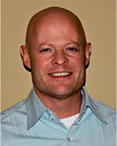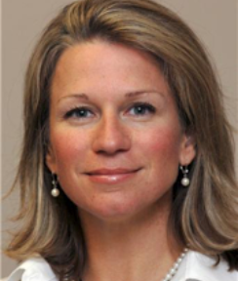
Dr. Darren Brucken Joni Wise
Health Officer Administrator

Vision: Healthy People in Healthy Communities
Mission: Promote physical & mental health, prevent disease, injury and disability
Public Health Goals
- Prevents epidemics and the spread of disease
- Protects against environmental hazards
- Prevents injuries
- Responds to disasters and assists communities in recovery
- Assures the quality and accessibility of health services

Essential Public Health Services
- Monitor health status to identify community health problems
- Diagnose and investigate health problems and health hazards in the community
- Inform, educate and empower people about health issues
- Mobilize community partnerships to identify and solve health problems
- Develop policies and plans that support individual and community health efforts
- Enforce laws and regulations that protect health and ensure safety
- Link people to needed personal health services and assure the provision of health care when otherwise unavailable
- Assure a competent public health and personal health care workforce
- Evaluate effectiveness, accessibility, quality of personal and population-based health services
- Research for new insights and innovative solutions to health problems

Programs and services are developed, implemented, evaluated, and revised if needed, to enable carrying out the essential public health services and meet the public health goals.

VIGO COUNTY HEALTH DEPARTMENT

Darren Brucken, M.D., Health Commissioner

Administration
Joni Wise, Administrator
Travella Myers, Deputy Administrator
Rhonda Coombs, Bookkeeper
Beth Morse, Purchasing Clerk

Environmental Health Division
Travella Myers, Supervisor
Steve Thompson, Wastewater Specialist
Amanda Bales, Food and Lead Specialist
Marci Shaw, Food, Lead, Water and Body Art Specialist
Rhiannon Cruse, Food Specialist
Jerica Robinson, Wastewater Specialist

Health Education/Media Coordination
Roni Elder

Vector Control Division Vital Statistics Division
Mike Grayless, Supervisor Loretta Nicoson, Supervisor
Tony Grayless, Assistant Supervisor Cheryl Clements, Registrar
Warren Sweitzer, Assistant Brandie Draser, Registrar
David Higgins, Assistant Brooke Foltz, Registrar
Logan Edwards, Assistant Jessica Kiger, Registrar
Kim Edwards, Secretary
Karen Beal, Seasonal

Nursing Division
Catherine Brown, M.D., Pediatrician
Andrea Craft, RN, Staff Nurse
Twyla Spidel, RN, Staff Nurse
Chelsea Willis, RN, Staff Nurse
Dolly Moss, Secretary
Teresa Bechtel, Immunization Registry Clerk
Robin Maurer, Insurance Billing Specialist

FINANCIAL REPORT FOR 2019

Cash Balance in General Health – January 1, 2019 $1,023,533.64
Receipts January 1 – December 31, 2019 $ 1,680,895.93
Expenditures January 1 – December 31, 2019 $ 1,700,729.64
Cash Balance in General Health – December 31, 2019 $ 1,003,699.93

Cash Balance in Health Donation – January 1, 2019 $ 36,437.37
Receipts January 1 – December 31, 2019 $ 12,908.45
Expenditures January 1 – December 31, 2019 $ 19,189.62
Balance in Health Donation – December 31, 2019 $ 30,156.20

Cash Balance Carry Over in Health Maintenance – January 1, 2019 $ 18,827.81
Cash Balance in Health Maintenance – January 1, 2019 $ 0.00
Receipts January 1 – December 31, 2019 $ 72,672.00
Expenditures January 1 – December 31, 2019 $ 56,895.34
Cash Balance as if December 31, 2019 $ 34,604.47

Cash Balance Coroner’s Fund January 1, 2019 $ 1,359.00
Receipts January 1 – December 31, 2019 $ 19,152.00
Expenditures January 1 – December 31, 2019 $ 18,792.00
Cash Balance December 31, 2019 $ 1,719.00

Cash Balance Health Trust January 1, 2019 $ 53,048.48
Receipts January 1 – December 31, 2019 $ 44,597.58
Expenditures January 1 – December 31, 2019 $ 47,437.28
Cash Balance – December 31, 2019 $ 50,208.78
Cash Balance in voucher submitted Immunization Grant: January 1, 2018 $ -7,201.12
Receipts January 1 – December 31, 2019 $ 54,043.61
Expenditures January 1 – December 21, 2019 $ 47,478.68
Balance as of December 31, 2019 $ -636.19

Cash Balance in Non-Reverting January 1, 2019 $ 1,568.84
Receipts January 1 – December 31, 2019 $ 6,932.44
Expenditures January 1 – December 31, 2019 $ 3,763.04
Balance as of December 31, 2019 $ 4,738.24

ENVIRONMENTAL HEALTH DIVISION



Environmental Health Division protects public health and the environment by ensuring conformance with State laws and County ordinances pertaining to a wide variety of environmental health programs. Much of this work is accomplished by performing routine inspections and investigations and taking enforcement action when warranted. The Environmental Health Division also interacts with various federal, state, regional, and local governmental agencies associated with environmental health programs.
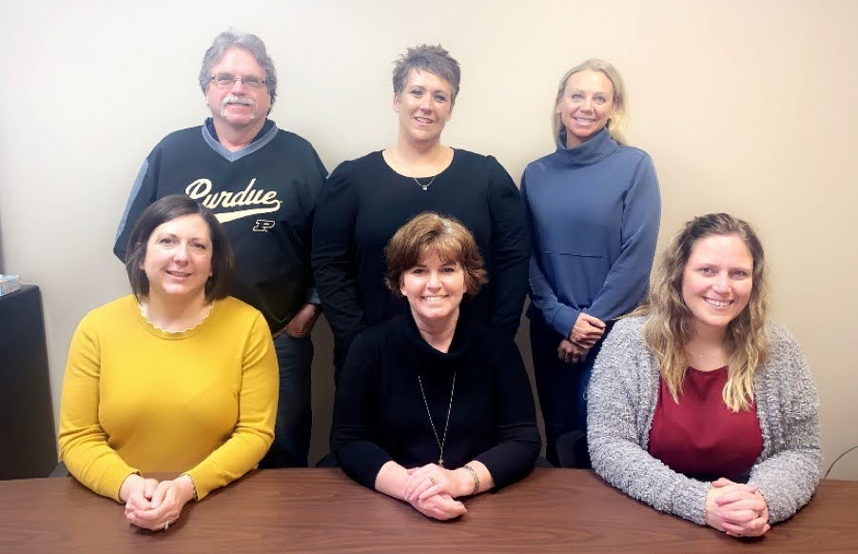
L-R Marci Shaw, Travella Myers and Jerica Robinson
L-R Steve Thompson, Amanda Bales and Rhiannon Cruse

FOOD SAFETY PROGRAM

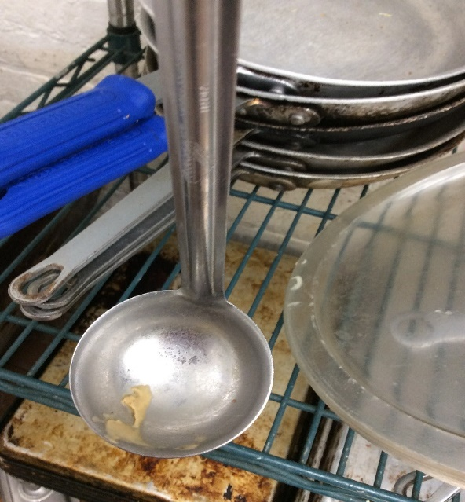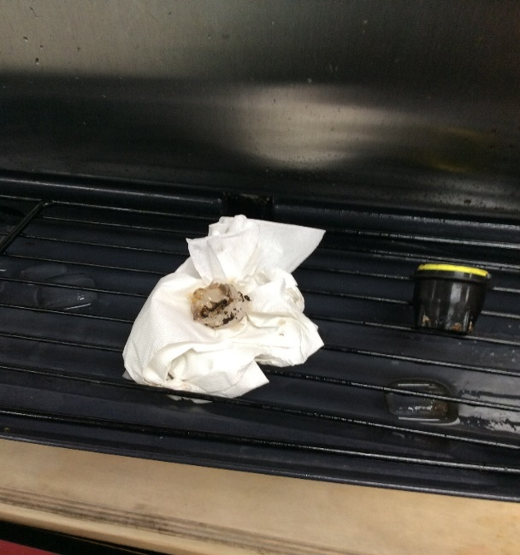
Some typical violations found in restaurants
The Food Safety Program involves the planning of new and remodeled retail food establishments, planning of fairs and festivals in Vigo County, and the licensing and inspecting of all retail food establishments within Vigo County. We work closely with the Indiana State Department of Health on any food recalls and food borne illnesses.
By promoting food safety education and fostering understanding, communication, and cooperation among regulators, industry and consumers, VCHD seeks to provide the best public health and consumer protection in an expeditious and cost-effective manner.

Permits Printed:
- 541 Retail food establishments
- 117 Temporary food stands
- 22 Mobile units
- 6 Farmer’s Markets

Inspections Conducted:
- 737 routine inspections
- 10 follow-up inspections
- 31 plan reviews
- 31 opening inspections

WASTEWATER MANAGEMENT PROGRAM

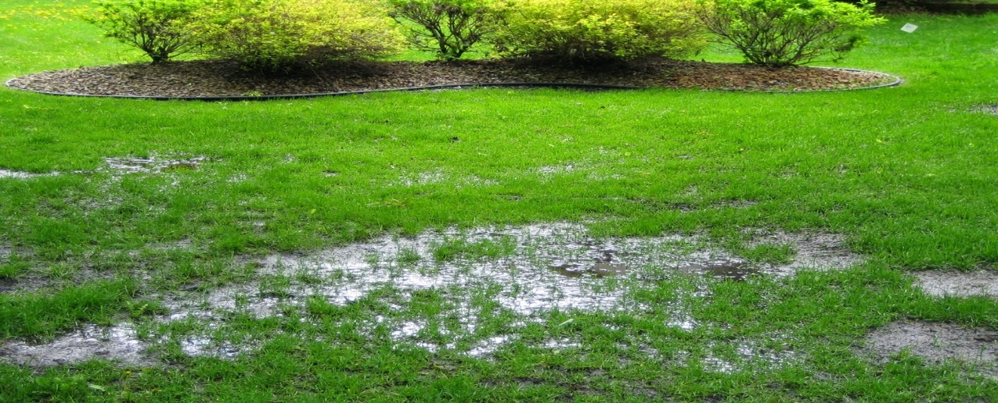
Failing Septic System
An on-site system is one which treats the sewage in a septic tank so that most of the sewage becomes effluent and is disposed of in an area close to the house or buildings. An example of an on-site disposal system consists of a septic tank and leach drains.
The planning, installation, and repair of on-site sewage disposal systems must be reviewed and inspected by one of our full-time environmental health specialist. This includes the reviewing of soil scientist reports, drawing of installed systems for department records, and giving recommendations for proposed subdivisions.
A total of:
- 86 Septic Permits
- 40 Subdivisions
- 313 Improvement Location Permits

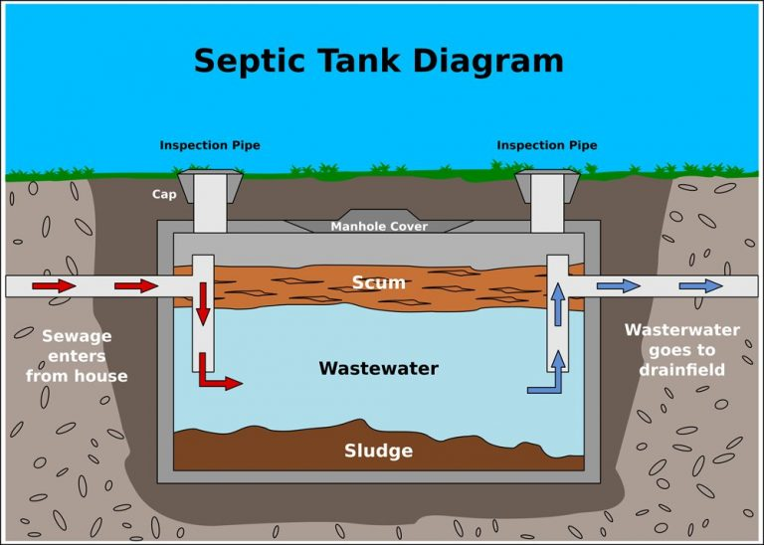

RECREATIONAL WATER PROGRAM


Waters used for recreational purposes are subject to a variety of environmental influences which can affect the health and/or safety of individuals using those waters. According to a recent report from the Centers for Disease Control and Prevention. Between 2000 and 2014, researchers said, 493 disease outbreaks were reported from public swimming holes, such as hotels and hot tubs. Thirty-two percent of those outbreaks, defined as when at least two people reported similar illnesses, occurred in hotels.
In April 2019 a new ordinance went into effect establishing the standards for public pool facilities. A permit is now required for public swimming pool facilities operating in Vigo County. This includes the inspection and review of bacteriological reports of swimming and wading pools, spas, therapy pools, and public access beaches. The inspection entails an evaluation of the pool area, water quality, safety equipment, and mechanical room.
The goals of this ordinance is to minimize safety hazards, reduce the potential for disease transmission and assure that waters used for recreational purposes are operated and maintained in compliance with the applicable ordinances.
- 158 Regular inspections were performed
- 28 Follow-up inspections
- 49 Closings
- 1 Opening
- 42 Permitted

BODY ART SAFETY PROGRAM

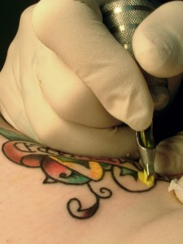
The use of improperly sanitized needles and instruments for invasive procedures on the human body and/or procedures being completed by inadequately trained individuals can contribute to the spread of communicable diseases and/or cause permanent injury.
Through the Body Art Safety program the Environmental Health Specialist works to ensure the safe and proper operation of the licensed body art establishments in Vigo County. We educate operators, evaluate plan reviews, and perform opening inspections on new or remodeled body art establishments. We also ensure general safety and sanitation standards, and proper disposal methods of infectious waste.
The Artist licensing program ensures the individuals that are performing the body art are knowledgeable and competent.

- 9 Body Art establishments licensed
- 7 Routine inspections
- 40 Artist Licenses

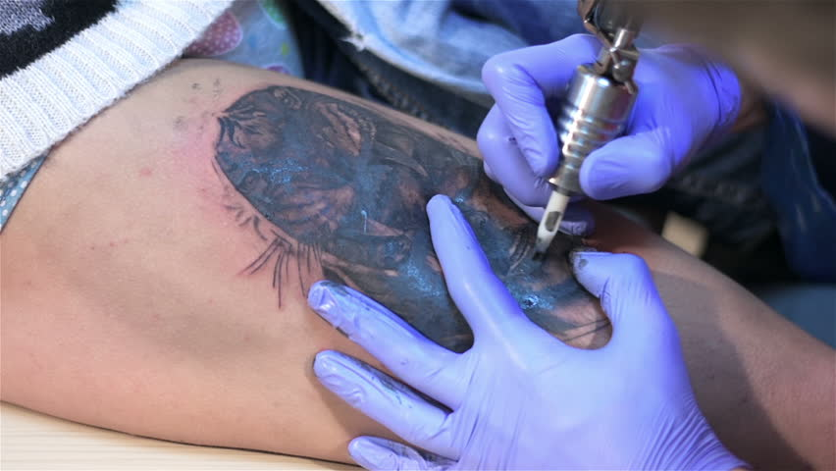
LEAD POISONING PREVENTION PROGRAM
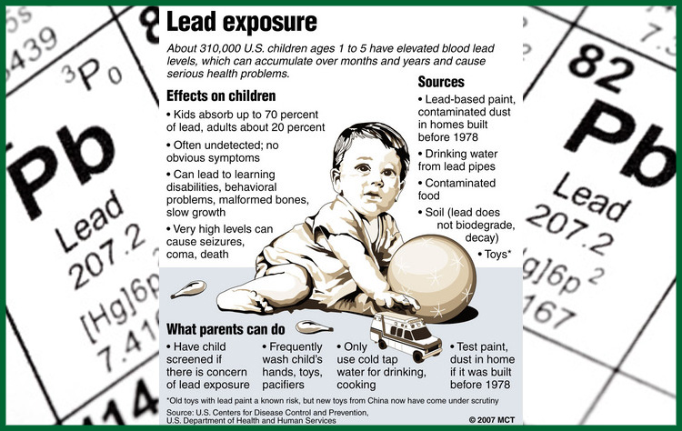
Lead was a common ingredient in house paint where it acted as a pigment and increased durability. This was before the dangers of lead were known. Though banned for use in paint in the U.S. in 1978, millions of homes, schools, and businesses still have lead based paint on their walls, both inside and out. According to the Environmental Protection Agency, lead paint can be found in:

- 24% of homes built from 1960-1978
- 69% of homes built from 1940-1960
- 87% of homes built before 1940

We have two licensed Risk Assessors that address the lead risks in the homes of the children that have elevated blood lead levels. The Risk Assessors educate the families on proper cleaning procedures and mitigation choices when lead risks are identified. Additionally a Public Health Nurse follows that child until their blood lead levels drop below the mandated 10 μg level.

- 23 open cases
- 1 new cases
- 10 risk assessments
- 1 clearance exam



If the paint is in good condition and has been painted over, it usually doesn’t pose a problem. But if the paint is peeling or has been disturbed by scraping, sanding, or burning, it can pose significant health risks to people especially young children.
The state of Indiana mandates the local health department to follow children with elevated blood lead levels of 10 μg or more and to follow up services to provide parent education and blood testing of children with elevated blood lead levels of 5 μg/dL of blood or more. This includes educating the parents and conducting a risk assessment of the home.

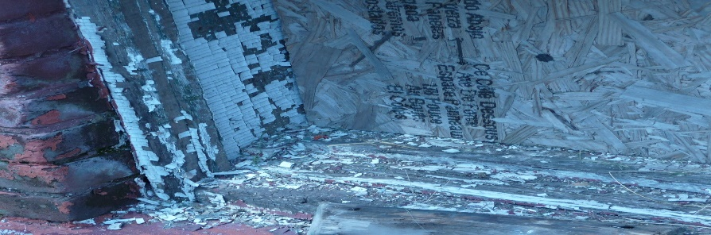
Lead based paint in very poor condition
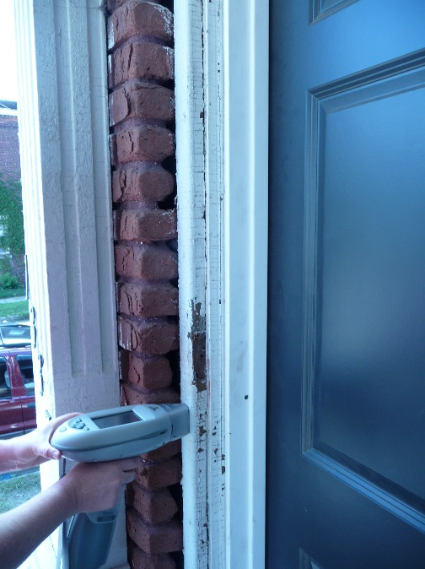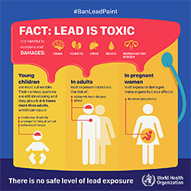
Marci Shaw using an XRF to detect lead paint Lead Facts

PUBLIC HEALTH COMPLAINT PROGRAM

Housing and property complaints filter through this program. Some of the problems addressed are: mold, rodents, roaches, animal feces, meth lab clean up, surfacing sewage, and human feces. We are called by other agencies, such as Child Protective Services, Adult Protective Services, City and County Building Inspection, City Environmental, City and County law enforcement.
- 28 surfacing sewage complaints
- 3 unfit housing situations
- 2 animal feces complaints
- 29 bed bug complaints
- 18 mold complaints

- 8 Meth Lab letters

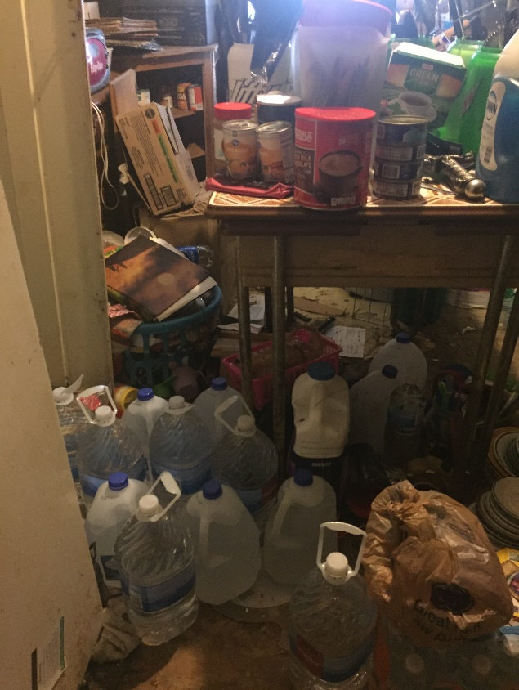
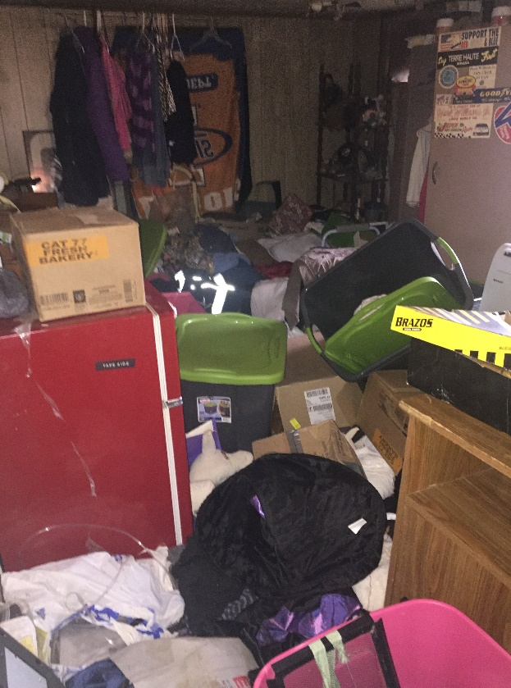

DRINKING WATER PROGRAM


Clean water is vital to our health, communities, and economy, it is a fundamental human need. Each person on Earth requires at least 20 to 50 liters of clean, safe water a day for drinking, cooking, and keeping themselves clean.
The drinking water program includes the review of water sampling results from daycares, mobile home parks, and retail food establishments that utilize well water; education on proper care and shocking of wells, and guidance when flooding is an issue.
We have also been involved with the local water company when we have found homes with high levels of lead in their water due to old city water lines that had not been replaced.

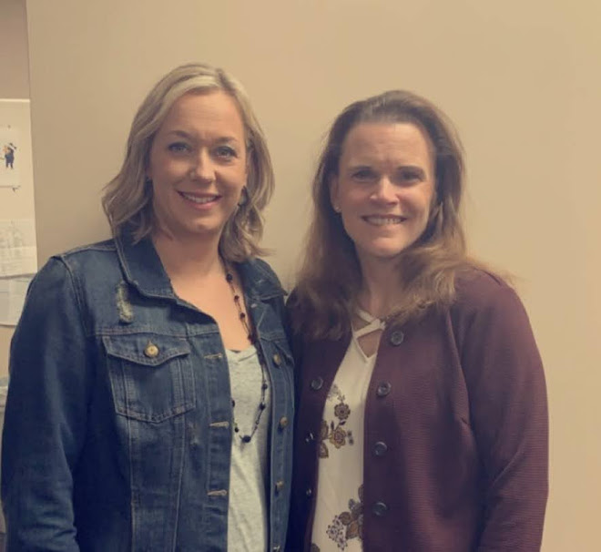
Purchasing Clerk, Beth Morse and Bookkeeper, Rhonda Coombs
Bookkeeping and purchasing are an important part of the Vigo County Health Department. We manage funds and purchases with allocation by the Vigo County Council, Indiana State Department of Health and State Board of Accounts. Our goal is to conscientiously and prudently utilize funds to the benefit the public we serve. We make financial decisions based on the assessed needs of our employees and their divisional programs. As with many government agencies, we have had less funds over the last ten years, so we have become ingenious in our planning and spending. The bookkeeper and purchasing clerk also assist the Environmental Health Division as support staff as well as being an integral part of our team of twenty six full time employees, six part-time employees and two contractual positions.

PUBLIC HEALTH CLINIC
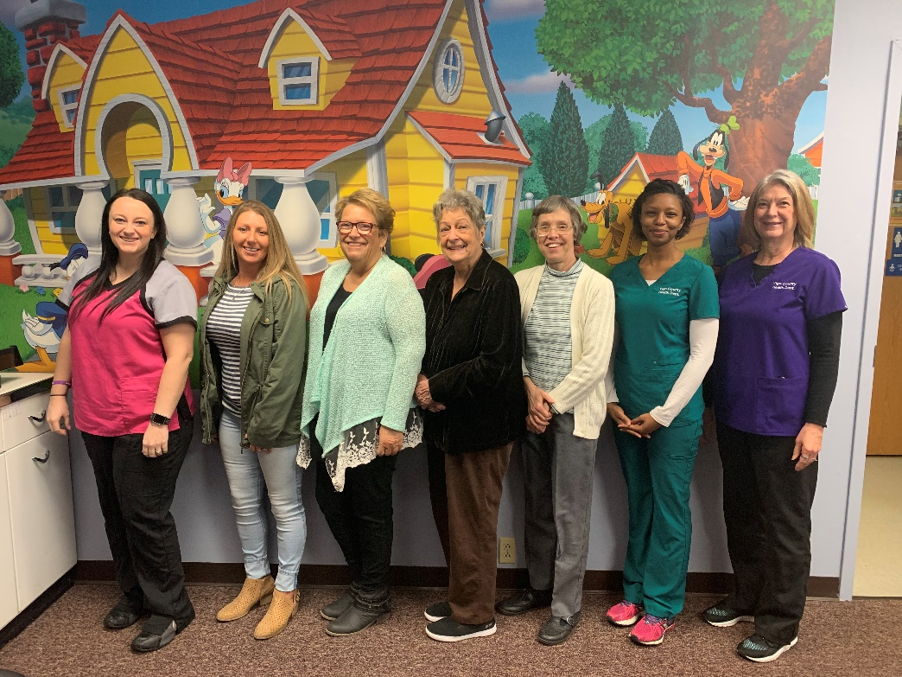
Chelsea Willis RN, Robin Maurer, Teresa Bechtel, Dolly Moss, Dr. Catherine Brown,
Andrea Craft RN, & Twyla Spidel RN.

VACCINE FOR CHILDREN PROGRAM/PRIVATE PAY
The VCHD Clinic is a provider enrolled in the Vaccines for Children program and provided childhood immunizations to those who qualified. With some of the pediatricians in and around town not carrying immunizations, the VCHD helped immunize those children. Most major insurances were accepted at the VCHD with the help of Vaxcare.

ADULT VACCINE PROGRAM/ADULT WELL PHYSICALS
The Adult Stay Well Program was continued by Dr. Brown who provided adult physicals which included college students, daycare employees, and foster care parents for a nominal fee. The VCHD is enrolled in the Vaccines for Adults program to provide immunizations for adults with no insurance or insurance that does not cover vaccines.

COMMUNITY INVOLVMENT
Immunizations are an important part of what the nurses at the Vigo County Health Department do on a daily basis. Approximately 195 flu vaccines were given to Vigo County Employees in the fall of 2019. The VCHD nurses serve as clinical preceptors for nursing students from Indiana State University and Saint Mary of the Woods College. The Health Department nurses, Twyla Spidel RN, Chelsea Willis RN, and Andrea Craft RN, sit on the Vigo County Immunization Task Force; which meets quarterly with other medical professionals, school nurses, and childhood development members to collaborate and create new ways to increase immunization rates for Vigo County.

EPIDEMIOLOGY AND COMMUNICABLE DISEASE

Indiana Code 16-41-2-1 requires local health departments to investigate and report communicable diseases listed in the Indiana State Department of Health Communicable Disease Reporting Rule. Once the investigations are completed, they are entered into the computerized data base known as the Indiana National Electronic Disease Surveillance System (NBS). VCHD Clinic nurses investigate and reported communicable disease cases in 2019. Chronic Hepatitis C continued to be the most prevalent communicable disease investigated by the VCHD in 2019.
 | totals 2017 | Totals 2018 | Totals 2019
Animal Bites | 146 | 167 | 10 Investigated
Campylobacteriosis | 19 | 14 | 19
Carbapenemase-producing carbapenemase-resistant enterobacteriaceae | 1 | 36 | 7
Chicken Pox | 5 | 2 | 4
Hepatitis C | 110 | 182 | 272
Hepatitis A | 1 | 2 | 46
Histoplasmosis | 4 | 4 | 0
Lyme Disease | 5 | 1 | 2
Streptococcus A | 1 | 5 | 2
Streptococcus Pneumoniae | 14 | 16 | 24

*This table includes cases that might not be determined. Investigation must be initiated in order to make a final determination. Not publicly reported it total is less than 5. Hepatitis C count includes Federal Prison for 2019.

LEAD SCREENING
In 2019, approximately 101 children were screened for lead poisoning. We held many lead screening outreach clinics throughout the county such as Head Start, Early Head Start, and ISU Early Childhood Center. Lead poisoning case management and environmental lead risk assessment consists of patient cases that are over the level of 10 mcg/dl for venous blood lead levels. The Lead Case Manager had 18 lead cases >10mcg/dl and 1 home investigation.
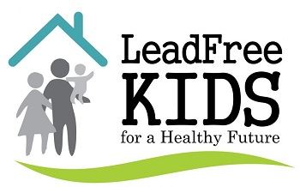

INDIANA STATE IMMUNIZATION GRANT

A grant was awarded to the Vigo County Health Department Nursing Division by the Indiana State Immunization Division in 2019 for $75,407. Funds from this grant were used in various ways to increase immunization rates and promote services offered at the health department clinic. The VCHD Clinic was able to purchase various supplies and equipment. Since the immunization grant was started in 2014, immunization rates in Vigo County have increased from 28% to 72% in 2019. The grant funded the VCHD Clinics ability to accept most private insurances. A total of 667 private insurance clients were administered vaccines in 2019.
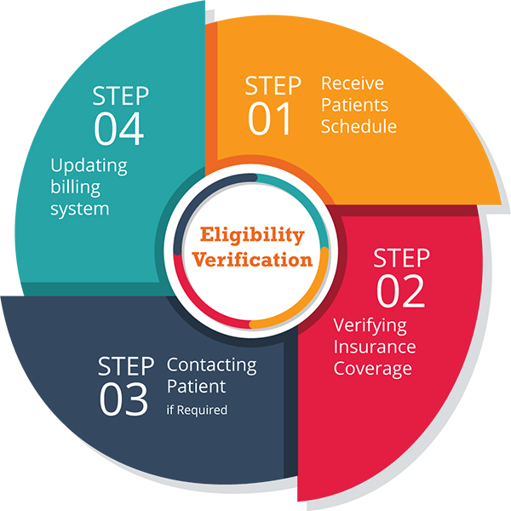

TUBERCULOSIS CASE MANAGEMENT AND TESTING

Tuberculosis (TB) control and case management by the local health departments is a mandated task under the Indiana Code 410 IAC 1-2.3-106. This includes investigating positive skin tests, collection of sputum samples for evaluation by the ISDH lab, providing medications for both active and latent TB cases, home visits for medication administration, evaluation and testing for contacts of the infected patient, communication with the patient’s physician, and patient education. In 2019, 0 active TB cases, 0 suspected, and 20 latent TB cases were managed by the VCHD Clinic. In addition, the VCHD Clinic provided TB skin testing on a walk in basis on Monday and Friday for the community for a nominal charge. 1,325 TB skin tests were administered in 2019.

EDUCATION
The public health nurses attended numerous training and educational courses throughout the year: Drug Task Force Meeting, PTR Connect Meeting, World TB Day, School Nurse Meeting, Landsbaum Center Substance Abuse Symposium, Public Health Nurse Conference, HPV Conference, Lead Conference, Infectious Disease Summit, and Labor of Love. There were also trainings done in the VCHD Clinic.
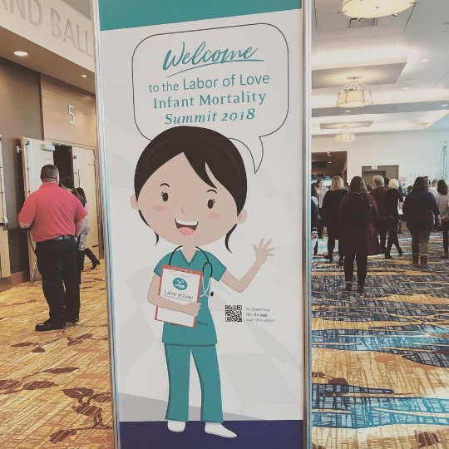
ISDH, Kristina Box, M.D. leading the conversation at the Labor of Love Summit,
The Labor of Love Summit is a product of the Indiana State Department of Health in cooperation with other organizations. Infant mortality is the death of a baby before his or her first birthday. The United States is one of the wealthiest countries in the world, yet it has an unacceptably high rate of infant mortality. The problem is particularly significant in Indiana, where the overall infant mortality rate was 7.5 infant deaths for every 1,000 live births in 2016. To combat unacceptable rates of infant mortality in Indiana, ISDH, through its Maternal and Child Health program, is initiating a statewide sustained education and outreach effort. This has been identified as the agency’s No. 1 priority.

HEALTH EDUCATION / MEDIA COORDINATION

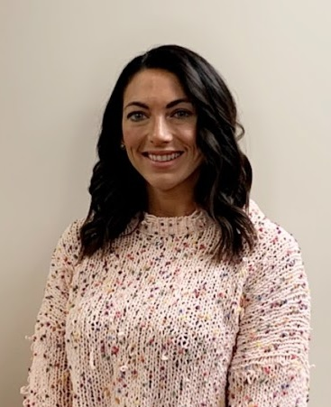

Roni Elder

Health Education is the process of assisting individuals and groups to make informed decisions and build skills on matters affecting personal, family and community health. Health Education provides information about awareness and prevention with the goal of providing Vigo County Citizens with the opportunity to reach their fullest potential. Health Education utilizes the following outlets to provide education:

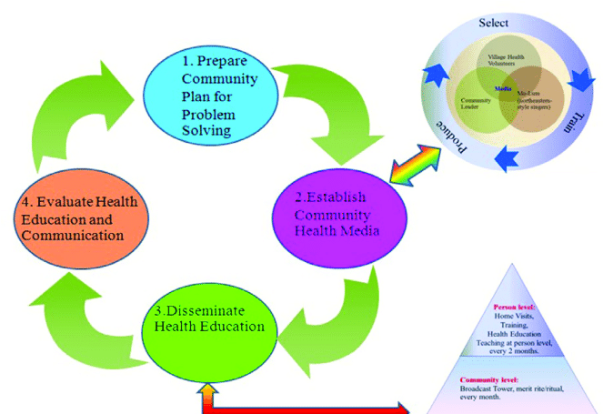

PRESENTATIONS
Presentations offer a comprehensive look at today’s public health issues that are of concern. Some presentations are multi-faceted, such as an overview of the Health Department and its role in public health in Vigo County while others can be an in-depth look into issues such as bedbugs, influenza, or tobacco use in our community. This involvement offers the public the opportunity to learn about their health and well-being, ask questions, and become familiar with the Health Department. The Vigo County Health Department works collaboratively with many community partners which include but are not limited to; the Vigo County School Corporation, Hamilton Center, Vigo County Head Start, and Indiana State University.
The following is a brief list of programs & presentations conducted by the Health Department:
- County Employee CPR Program
- Brownstone Manor Healthy at all Ages
- Presentation at Library over Harm Reduction
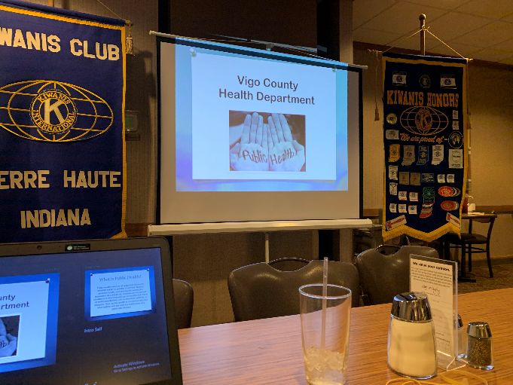
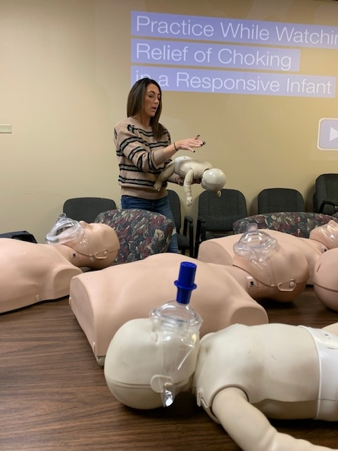
- Kiwanis Presentation
Roni Elder teaching C.P.R Presenting for the Kiwanis Club

HEALTH FAIRS
Health fairs are a great way to promote health awareness and encourage participants to take responsibility for their health and provide valuable health information. Health fairs allow health department employees the opportunity to meet with the public and discuss their specific concerns in locations that are convenient and easily accessible. This year, Vigo County Health Department participated in the following health fairs:

- Terre Haute Community Baby Shower
- Commissioner’s Job Fair
- Mom & Baby Community Health Fair
- New & Expecting Father’s Health Fair
- Anthem Health Fair

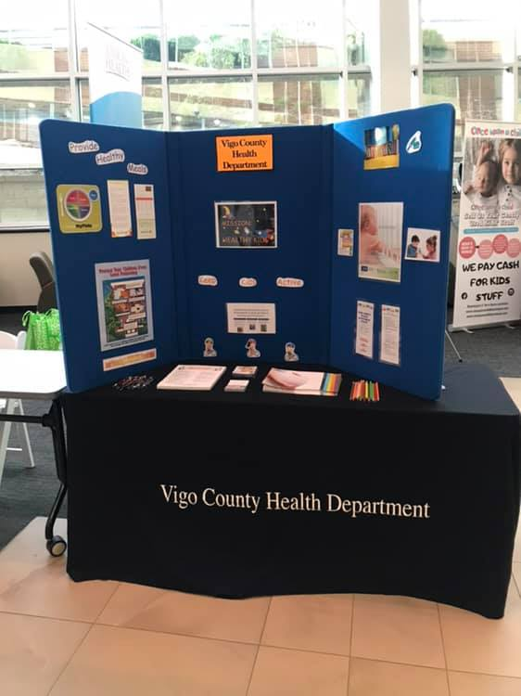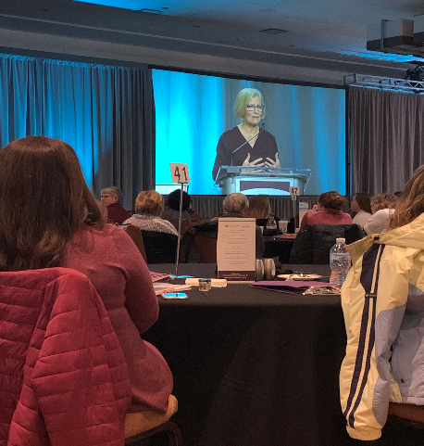
CONTINUING EDUCATION

- National Immunization Conference
- Labor of Love Summit
- ISDH District Training
- The Brain & the Disease of Addiction
- Opioid Public Health Crisis
- The Language of Recovery
- Substance Abuse Disorder
- Harm Reduction
- Cervical Cancer Prevention
- Side Effects- Youth & E-Cigs Webinar
- Lunch & Learn
- District Training; Measles and Mumps
- Internal Control Human Resource Training
- Perfectly Pierced
- Maternal Immunizations

MEDIA PARTNERSHIPS

Working with the media is an extremely important component of Health Education. In order to ensure the residents of Vigo County receive the most accurate and up to date health information, the Vigo County Health Department has developed an excellent relationship with the media. The Health Educator/Media Coordinator works diligently with media outlets to compose important health messages in order to promote, provide, and protect the citizens of Vigo County and the surrounding areas. The following health topics were covered in the media:

- Influenza
- Cold Weather Safety
- Board of Health Meetings
- Tire Amnesty Program
- Hepatitis A
- Recovery Alliance
- Heart Healthy Month
- Mosquitos
- West Nile
- Fogging Schedule
- Measles
- County Rankings
- Bed Bugs
- Food Safety/Leftovers
- Food Permits/Mobile Units
- Spring Weather
- Open Door Ordnance
- Evers
- Healthy & Safe Swim
- Tattoo Ink Recall
- Ticks

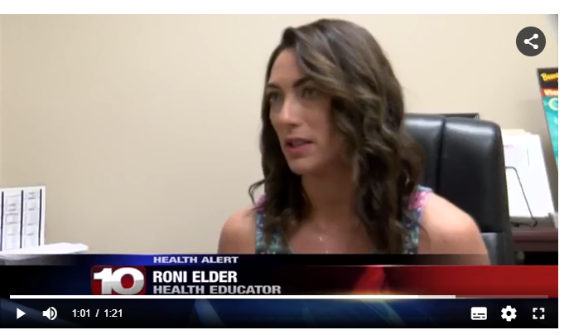

SOCIAL MEDIA

An always evolving, key piece of Health Education is our Social Media presence. We are very excited to now be a part of Facebook, Twitter, LinkedIn, YouTube, Pinterest, and Instagram! With the ever growing usage of social media sites it is crucial to use that to our advantage in reaching the public in every way possible for education and information. The use of social media in emergency situations such as an outbreak or natural disaster is also one of our main reasons to jump on board. Our goal is to provide the most accurate, up-to-date information as quickly as possible to our community. If you haven’t already come visit our pages!
COMMUNITY INVOLVEMENT

Health Education and Media Coordination works collaboratively with hundreds of Vigo County members in order to provide fast, reliable, and educational information to our citizens.
- Tobacco Prevention Cessation Coalition
- Preparedness Planning Coalition
- Environmental Coalition
- Child Fatality Review Committee
- Drug Free Vigo County
- Health Education Advisory
- Vigo County Jail
- Wabash Valley Recovery Alliance
- Homeless Coalition
- Next Step
- Group Homes
- Crisis Pregnancy Center
- Parks Department
- Hamilton County
- Lamar
- CODA
- Office of the Indiana Attorney General
- Chances and Services for Youth
- Vigo County School Corporation
- Vigo County School Nurses
- Indiana State University
- Lighthouse Mission
- United Way
- Better Health Wabash Valley
- Lugar Center
- IU School of Medicine
- Healthy Start Grant
- Helping Children & Families
- Community Action Meetings

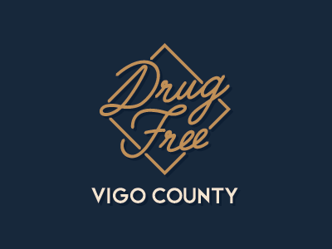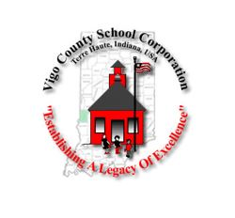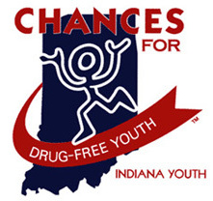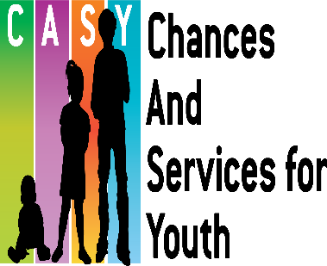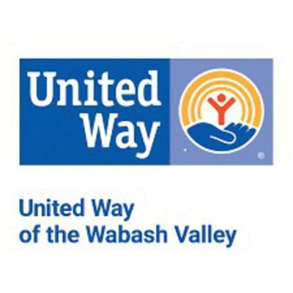

VITAL STATISICS DIVISION
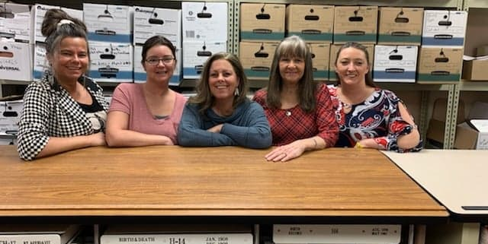
L to R: Loretta Nicoson, Jessica Kiger, Brandie Draser, Cheryl Clements and Brooke Foltz

THE VITAL RECORDS DIVISION’S OBJECTIVE IS TWO-FOLD
- Carry out uniform procedures
- Maintain and protect the integrity of the Vital Records Systems




THE DIVISION HAS THE RESPONSIBILITY TO:
- Maintain a system that accurately records all births, deaths and fetal deaths
- Efficiently issue certified copies of records
- Issue provisional notification of death-burial transit permits
- Process paternities when they come to us from the courts
- Type and process paternities when people schedule appointments to come in to our office
- Type affidavits of amendment and schedule appointments for people to make corrections to their birth record
- Work with funeral homes in filing death certificates
- Verify birth records for the Military, Social Security and Division of Family and Children
- Assist citizens who wish to inspect permanent birth and death records
- Assist customers in doing genealogy

VITAL STATISTICS ANNUAL REPORT 2019

BIRTHS REPORTED
In-Wedlock 1,012
Out-of-Wedlock 995
Total Births 2,007

HOME BIRTHS 0
STILLBIRTHS 37

DEATHS REPORTED 1,418

CORONER CASES 166
CORRECTIONS PROCESSED
Affidavit of Amendments 15
Adoption 157
Paternity Affidavit 57
Legal Name Changes 19
CODP 49
Total Corrections 296

BIRTH CERTIFICATES ISSUED 8,942

DEATH CERTIFICATES ISSUED 8,763

CERTIFICATES ISSUED FREE 499
GENEALOGY SEARCHES 117

NOTIFICATIONS OF DEATH 6,960

GENERAL HEALTH FUND $154,950.50

CORONER’S TRAINING AND EDUCATION FUND $18,949.50

TOTAL CASH RECEIVED $173,900

INDIANA VITAL RECORDS ASSOCIATION FALL CONFERENCE
IVRA proudly holds two separate conference opportunities each year. A spring and fall conference is available to all IVRA members and nonmembers. At conference new speakers are introduced, a business meeting is held, new members of IVRA are met, and we learn a whole lot! This is a great networking opportunity for Indiana Registrars.
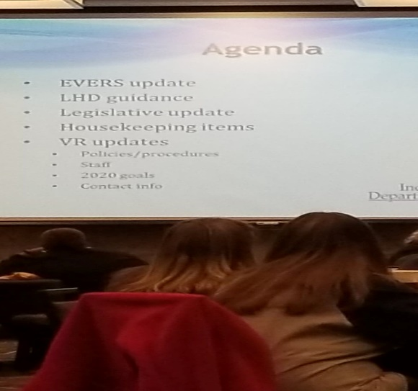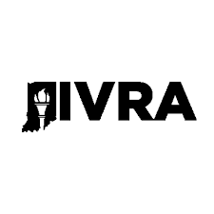

The Indiana Vital Records Association is an organization whose mission is to provide a forum for collaboration, cooperation, and communication through membership. The Association strives to accurately register and record, in a timely manner, the Vital Events of Indiana. The integrity of Vital Statistics is maintained through consistent procedures achieved through education, support and training to best serve its members and the public.

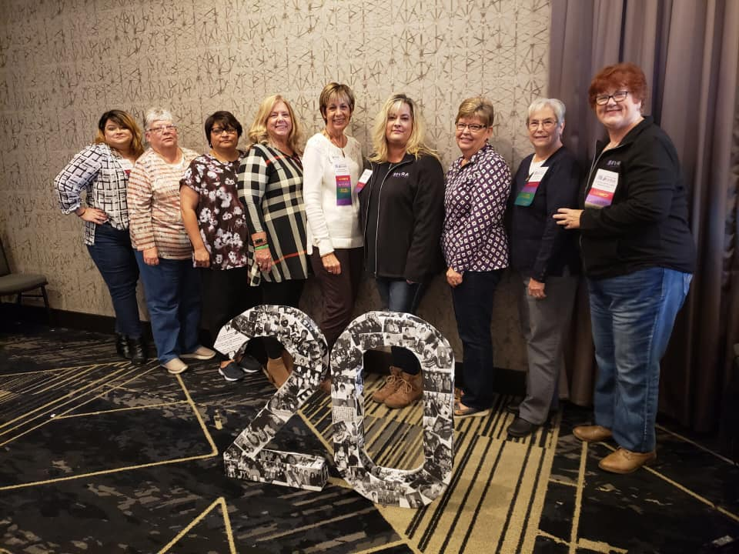

VECTOR CONTROL DIVISION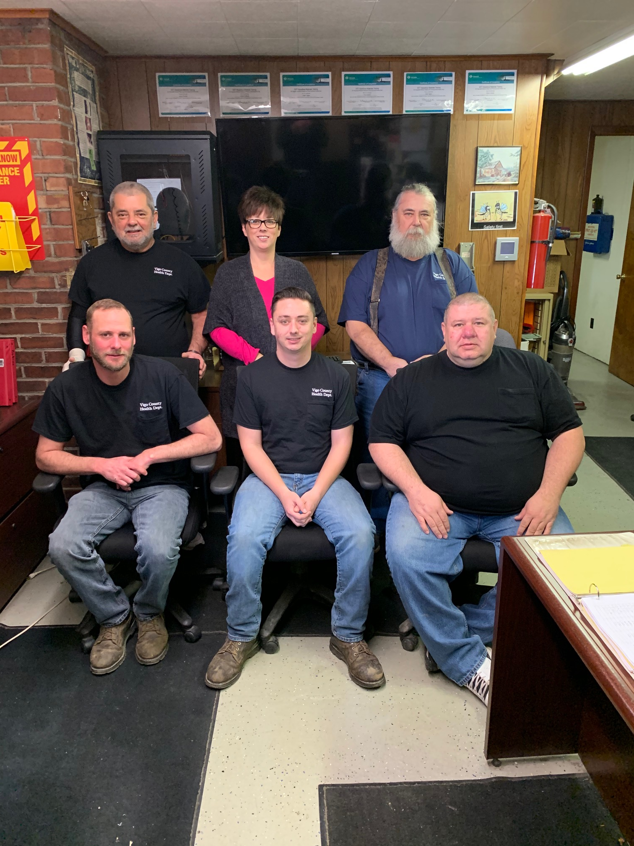L-R: David Higgins, Logan Edwards and Warren Sweitzer
L-R: Mike Grayless, Kim Edwards and Tony Grayless
The primary goal of the Vector Control Division is to reduce the risk of disease and death from pathogens carried by animals and/or vectors. The Vector Control Division also repairs and maintains all Health Department vehicles and spraying equipment.
A “vector” is an agent capable of transmitting a pathogen from one organism to another. (I.e. mosquito, rodent). The Vector Control Division devotes its time primarily to:

- Vector control
- West Nile surveillance
- Dead animal removal
- Fleet maintenance and repairs
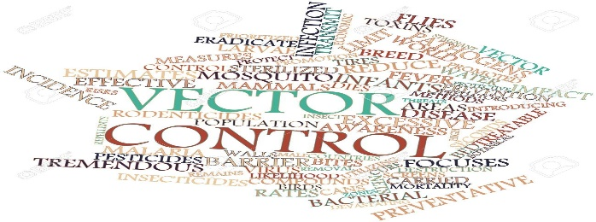

MOSQUITO CONTROL

The spraying for adult mosquitoes in Vigo County was as diligent as the weather would allow in 2019. The adulticiding program consists of five ½ ton pickup trucks and four ATVs (equipped with ultra-low volume cold aerosol fog machines) to spray insecticides throughout the county, as well as Terre Haute, for the control of adult mosquitoes. The ATV mounted ULV makes most sites accessible. All nine ultra-low volume-fogging machines must be certified for droplet size and calibrated for flow rate prior to each spraying season. Calibration is monitored daily throughout the spraying season. Adult mosquito control is accomplished using 4 insecticides: Bio-Mist 4+12, Kontrol 4X4, Aqua Duet and Aqua Anvil.
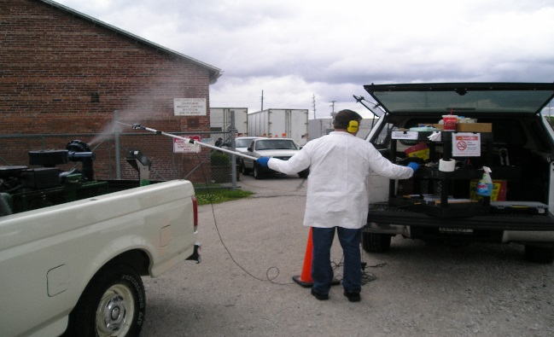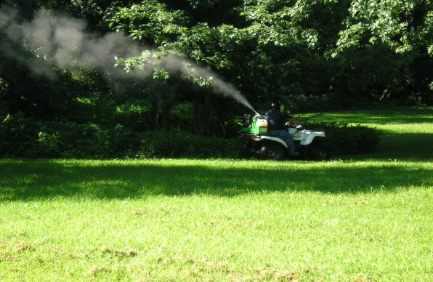
Chris Novak of Clarke Mosquito Control checking droplet size. Vector Control Assistant Supervisor Tony Grayless

All ULV units are fitted with GPS compatible “Smart Flow” systems. This enables Vector Control staff to preset and record calibration, time of spraying, flow rate and vehicle speed.
Vector Control staff prepares and updates 26 maps that are 40-45 miles of county and city roads. The 26 maps show the areas to treat and also areas that we do not treat, which we consider no spray zones. Some of the areas that are considered no spray zones might be areas with organic gardens, beekeepers, large bodies of water or persons who have requested no spraying be done in the area they live, either for health or personal reasons. The 26 maps are treated weekly, biweekly or monthly depending on adult mosquito population and weather conditions.

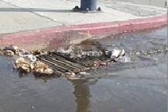
Vector Control employees spend an extended amount of time treating stagnant water for mosquito larvae. Several brands of insecticide targeting several species are employed to kill the larvae. One type of insecticide (Golden bear) can last for seven days in stagnant low area water, covering the surface of the water denying the mosquito larvae access to air. All “catch basins” or dry wells are treated with Altosid briquettes and Bactimas briquettes which lasts 30 or 150 days. Altosid Briquettes inhibit the growth of the larvae preventing them from becoming adults. Catch basins have been identified as one of many ideal habitats for the Vector (Culex pipiens), a mosquito notoriously known for the transmission of West Nile. Culex mosquito larvae love the stagnant dirty water left behind from rain that doesn't soak into the ground but runs off into catch basins, retention ponds, and roadside ditches.
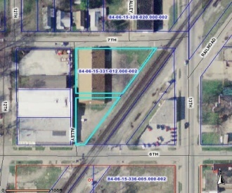
In 2019, approximately 1,410 catch basins were treated. That number will continue to increase due to community growth. Parking lots and subdivisions will install retention ponds and/or catch basins to contain water run-off. Catch basins and larvaciding sites are mapped out using the County’s GIS system. Larvae samples are examined for identification of species to insure proper insecticide treatment.

The following table contains a list of the amount and types of insecticide used in Vigo County to control adult mosquitoes and larvae in 2019.
 | INSECTICIDE | AMOUNT USED
55 Gallon Drum | Biomist 4 + 12 | 14 Drums
55 Gallon Drum | Kontrol | 23 Drums
55 Gallon Drum | Aqua Anvil | 6 Drums
55 Gallon Drum | Aqua Duet | 2.5 Drums
220 Per Case | Altosid Briquettes (150 Day) | 7 Cases
400 Per Case | Altosid (30 Day) | 200 Pieces used
100 Per Case | Bactimas Briquettes | 5 1/4 Cases
3/4 Gallon | Talstar P | 1/4 gallon
55 Gallon Drum | Golden Bear | 20 Gallons
44 lbs per Case | Abate | 2 Cases

WEST NILE VIRUS SURVEILLANCE
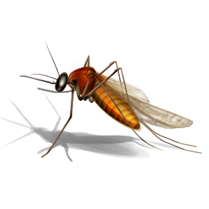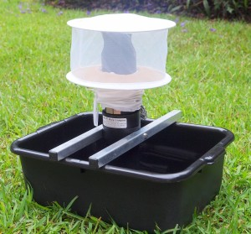
We use two different types of light traps. One type of light trap (CDC –CO2-Baited trap) uses dry ice or an attractant called “octonol” which simulates the exhaled respiratory gases of birds or mammals. The other is a gravid trap that uses alfalfa pellets mixed with water. The fermentation of these pellets releases an odor, similar to a livestock barn, and creates dirty, stagnant water that attracts gravid culex mosquitoes.
Light traps were set out at numerous locations throughout Vigo County with 2,501 mosquitoes being collected between June and October 2019. Once the mosquitoes are collected they are separated into groups ranging in number from 5 to 100 and are then labeled as pools of mosquitoes, which are sent to the Indiana State Department of Health for West Nile testing. A total of 85 pools were sent in for testing in 2019. The Indiana State Department of Health reported 1 positive pool for Vigo County. Vector control specialists will continue to set, maintain and collect mosquito pools for ISDH West Nile Virus testing in the upcoming year.
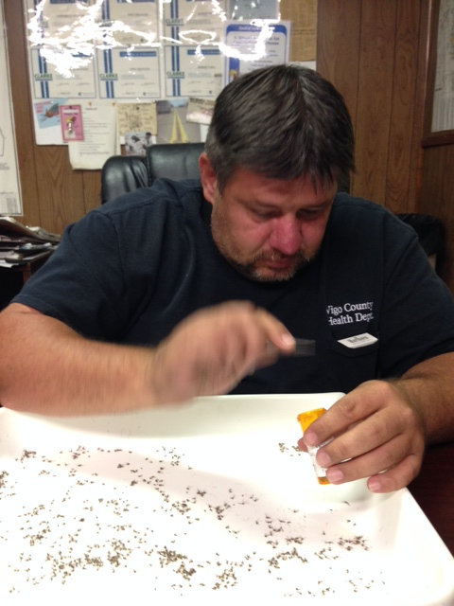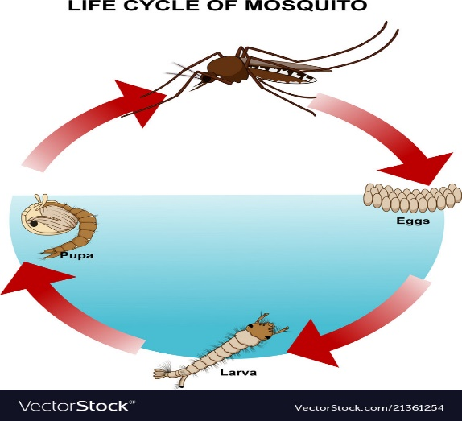
Warren Sweitzer counting mosquito samples Life Cycle of Mosquito

MOSQUITO BORNE DISEASE PREVENTION ACTIVITIES IN 2019:

- Distributed 5,400 “Skeeter Beater” coloring books to pre-school through 3rd grade elementary students on preventing and identifying prime breeding areas for mosquitoes.
- Worked with Home Owners (high grass, weeds, swimming pools, fishponds, standing water).
- Sent out Notice to Abate letters to all Vigo County cemetery caretakers.
- Participated in Clean up Terre Haute program in May and October 2019.
- Continued to monitor home owners, tire retailers and salvage yards to ensure compliance with the Tire Storage Ordinance.



2020 MOSQUITO AND LARVAE CONTROL STRATEGIES:

- Intensify local culex and aedes mosquito larval control to prevent the emergence of adult mosquitoes that feed on birds and contribute to the virus amplification transmission cycle.

- Continue active West Nile surveillance to determine the presence of new or expanding West Nile transmission. (Light traps-Adult mosquito testing)

- Reinforce public education and outreach programs to reduce mosquito- breeding sites around homes.

- Educate on personal protective measures (long sleeves, insect repellent) with the use of the media (TV, radio and newspapers).

- Implement local mosquito control to reduce the number of virus infected mosquitoes, thus reducing the immediate risk to humans.

- Monitor adult and larval mosquito control efforts to ensure that the local programs are effectively reducing mosquito densities and virus infection rates.

- Conduct inspections of local tire retailers and junkyards for tire storage ordinance compliance.

RODENTS
Rodents (i.e. rats, mice) are another source of disease transmission. Rodents must have adequate food, shelter, and water in order to survive. For these reasons, a large majority of rodent complaints are located within the city of Terre Haute.
A vector control specialist investigates complaints about rodents and proceeds to make recommendations to the property owner on findings and rodent control (i.e. removal of debris, animal feces). In some cases, the vector control specialist may set out bait and remove dead rodents, but the majority of the extermination is usually the responsibility of the property owner. A vector control specialist will continue to make follow up inspections to insure the property owner is correctly handling the problem.
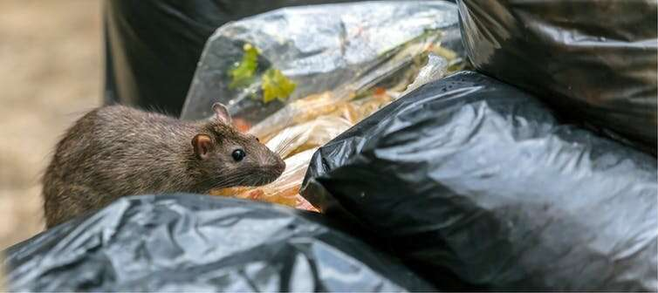
RABIES PREVENTION
In 2019 Vector Control staff sent 13 bats to the ISDH for rabies testing. One test result was positive for rabies virus. Night surveillance was performed by Vector Control staff at three homes in Terre Haute to assist the homeowners in bat proofing their homes.

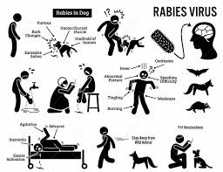

REMOVAL OF DECEASED ANIMALS

In 2019 a total of 462 deceased animals were removed from private properties, as well as city and county roadways and taken to the landfill.

VEHICLE MAINTENANCE

During the winter months the Vector Control Division is busy with repairing, cleaning and inspection of all vehicles and equipment. All ULV spray units must be cleaned and broken down during the winter months, checked, repaired and parts replaced as needed. Along with routine maintenance, all trucks and cars are thoroughly inspected and repaired. All Health Department vehicles and equipment have routine maintenance throughout the year.

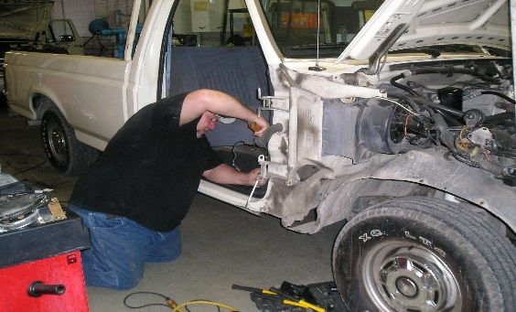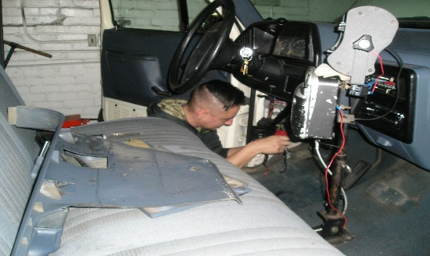
Warren Sweitzer repairing a vehicle Logan Edwards doing vehicle repair

TIRE AMNESTY CLEAN-UP PROGRAM

In 2019 Vigo County Health Department employees removed discarded tires from the alleys and streets of Terre Haute and surrounding communities. A total of 6,519 tires, filling four semi-trailers, were collected. Residents that had tires stored outside were given information on our Tire Storage Ordinance informing them that the tires must be stored inside or removed from the property.
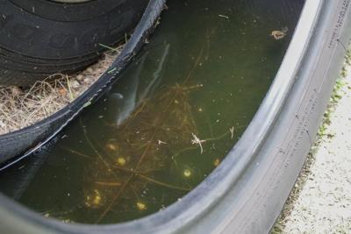

COMMUNITY INVOLVEMENT
TOYS FOR TOTS
In 2019 Vigo County Health Department employees donated money to purchase toys for the Toys for Tots program in Vigo County, over $2,000 was collected.
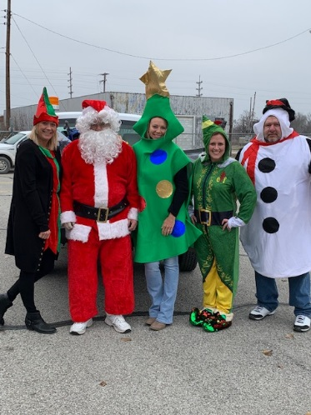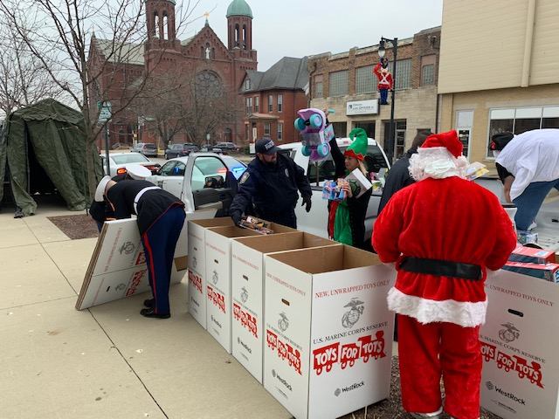
THE END

